SUBCOURSE EDITION
IT 0648 A

US ARMY INTELLIGENCE CENTER AND SCHOOL
EXTRACTING ORDER OF BATTLE
INFORMATION FROM
INTELLIGENCE REFERENCE MATERIAL

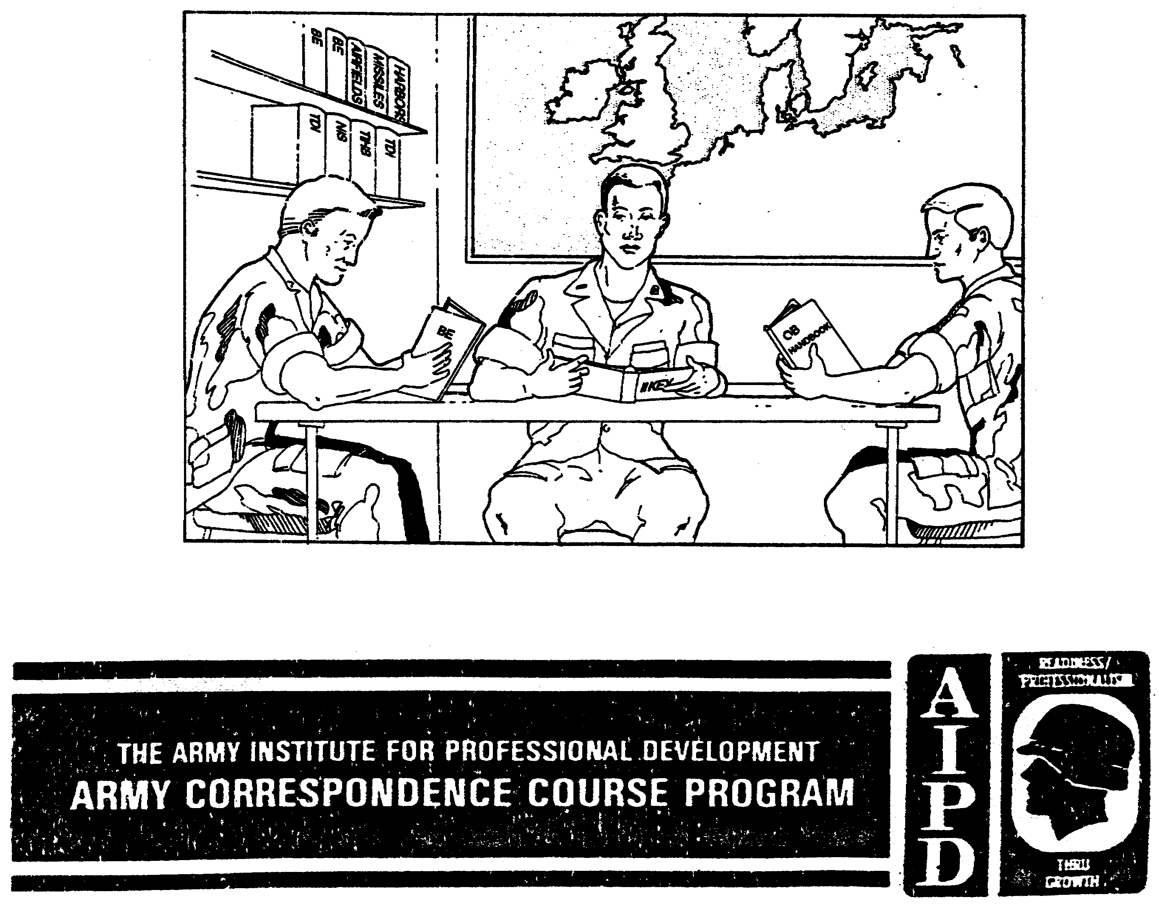

EXTRACTING ORDER OF BATTLE INFORMATION
FROM INTELLIGENCE REFERENCE MATERIAL

Subcourse Number IT 0648

EDITION A

US Army Intelligence Center and School
Fort Huachuca, Arizona 85613-7000

5 Credit Hours

Edition Date: September 1990

SUBCOURSE OVERVIEW

This subcourse is designed to teach you basic procedures involved with order of battle (OB) principles and using imagery analysis reference material.

There are no prerequisites for this subcourse.

This subcourse reflects the doctrine which was in effect at the time the subcourse was prepared. In your own work situation, always refer to the latest publications.

TERMINAL LEARNING OBJECTIVE

TASK: You will describe the intelligence cycle, OB elements, references, records, reports, files, and the Soviet field
forces organization.

CONDITIONS: You will have access to extracts from FM 34-1, FM 34-3, FM 100-2-1, FM 100-2-3, FM 101-5-1, STP 34-96D1-SM, STP 34-96D24-SM-TG, and TC 34-55.

STANDARDS: You will extract OB information from intelligence reference material in accordance with (IAW) FM 34-1, FM 34-3, FM 100-2-1, FM 100-2-3, FM 101-5-1, STP 34-96D1-SM, STP 34-96D24-SM-TG, and TC 34-55.

i IT 0648

TABLE OF CONTENTS

Section Page

Subcourse Overview i

LESSON 1: Order of Battle Principles and Intelligence
Reference Material 1
Part A: Intelligence Cycle 2
Part B: Order of Battle Elements 5
Part C: Order of Battle References, Records, Reports,
and Files 7
Part D: Soviet Ground Forces 33
Practice Exercise 38
Answer Key and Feedback 42

LESSON 2: Imagery Intelligence Reference Material 43
Part A: Operations Plan/Operations Order 44
Part B: Imagery Analysis References 45
Practice Exercise 48
Answer Key and Feedback 50

APPENDIX A: USSR Army Troops, Organizations, and Equipment 58
APPENDIX B: Intelligence Summary 83
APPENDIX C: Intelligence Summary for Joint Service Operations 84
APPENDIX D: INTSUM Message Format 88
APPENDIX E: Periodic Intelligence Report 91
APPENDIX F: Bombing, Shelling, and Mortaring Reports 94
APPENDIX G: Intelligence Annex 96
APPENDIX H: Division Intelligence Annex 99
APPENDIX I: Reconnaissance and Surveillance Appendix 109
APPENDIX J: Target Folder 114
APPENDIX K: Imagery Analysis Reports 123
APPENDIX L: II Keys 136
APPENDIX M: Acronyms 143

IT 0648 ii

LESSON ONE

ORDER OF BATTLE PRINCIPLES AND
INTELLIGENCE REFERENCE MATERIAL

MOS Manual Tasks: 301-338-3612
301-338-4101

OVERVIEW

TASK DESCRIPTION:

In this lesson you will learn to describe OB principles, to include the intelligence cycle; OB elements; OB references, records, reports, and files; and the Soviet ground forces organization.

LEARNING OBJECTIVE:

ACTIONS: Describe the information and procedures required to identify the intelligence cycle; OB elements, OB references, records, reports, and files; and Soviet ground forces organization.

CONDITIONS: You will be given access to extracts from FM 34-1, FM 34-3, FM 100-2-1, FM 100-2-3, FM 101-5-1, STP 34-96D24-SM-TG, and TC 34-55.

STANDARDS: Identification of the intelligence cycle; OB elements; OB references, records, reports, and files; and Soviet ground forces will be IAW FM 34-1, FM 34-3, FM 100-2-1, FM 100-2-3, FM 101-5-1, STP 34-96D24-SM-TG, and TC 34-55.

REFERENCES: The material contained in this lesson was derived from the following publications:

FM 34-1.
FM 34-3.
FM 100-2-1.
FM 100-2-3.
FM 101-5-1.
STP 34-96D24-SM-TG.
TC 34-55.

INTRODUCTION

Intelligence is the product resulting from the collection, evaluation, analysis, integration, and interpretation of all variable information which concerns one or more aspects of foreign nations or of areas of operations (AO) and which is immediately or potentially significant to military planning and operations.

1 IT 0648

PART A: INTELLIGENCE CYCLE

1. The commander's battle plan and supporting intelligence requirements constitute the driving force behind all intelligence operations. The commander, through the 62 or S2, directs the intelligence effort. The 62 or S2 develops intelligence requirements to support the commander's concept of operations. Intelligence operations concentrate on those priority intelligence requirements (PIR) and information requirements (IR) concerning the mission, enemy, terrain, troops, and time available (METT-T). PIR are those intelligence requirements for which a commander has a stated priority In planning and decision making. IR are those items of information regarding the enemy and environment which need to be collected and processed in order to meet the intelligence requirements of a commander.

2. Intelligence is developed through a process Known as the intelligence cycle based on the commander's mission. The cycle consists of four phases: directing, collecting, processing, and disseminating. It is a continuous process and even though each phase is conducted in sequence, all phases are conducted concurrently (Figure 1-1).

a. Phase 1: Directing the collection effort. This phase begins with the determination of requirements and priorities based on the PIR and IR. This is accomplished by the commander and intelligence and operations staff officers. Requirements are based on METT-T and the commander's planning guidance, requirements, and concept of the operation. The Intelligence analyst (MOS 96B) in the all-source production section (ASPS) advises the collection management officer (CMO) regarding the PIH and IR. They review the existing data base to identify information already available and what must be acquired. They pass requirements for new Information to the collection management and dissemination (CM&D) section as collection requirements.

b. Phase 2: Collecting the information is the process of gathering information from all sources. Based upon requirements, the CM&D section manages the collection effort. Upon receipt of a reconnaissance and surveillance (R&S) request the collection effort will be initiated. The CM&D section develops a collection plan that is keyed to METT-T, the commander's concept of the operation, and the current situation. It continuously updates the collection plan. In this phase of the intelligence cycle the agencies with collection capabilities are selected and sent specific orders and requests. The collection efforts are then supervised to verify that orders and instructions are executed effectively and in a timely manner.

c. Phase 3: Processing is the phase of the intelligence cycle whereby information becomes intelligence. Information from all sources is evaluated, correlated, and analyzed to produce an all-source product, it consists of three steps:

IT 0648 2

DIRECTING COLLECTING

REQUIREMENTS TROOPS
PRIORITIES INTEL SPECIALISTS
INDICATIONS SPECIAL UNITS
SELECTION OTHER SOURCES

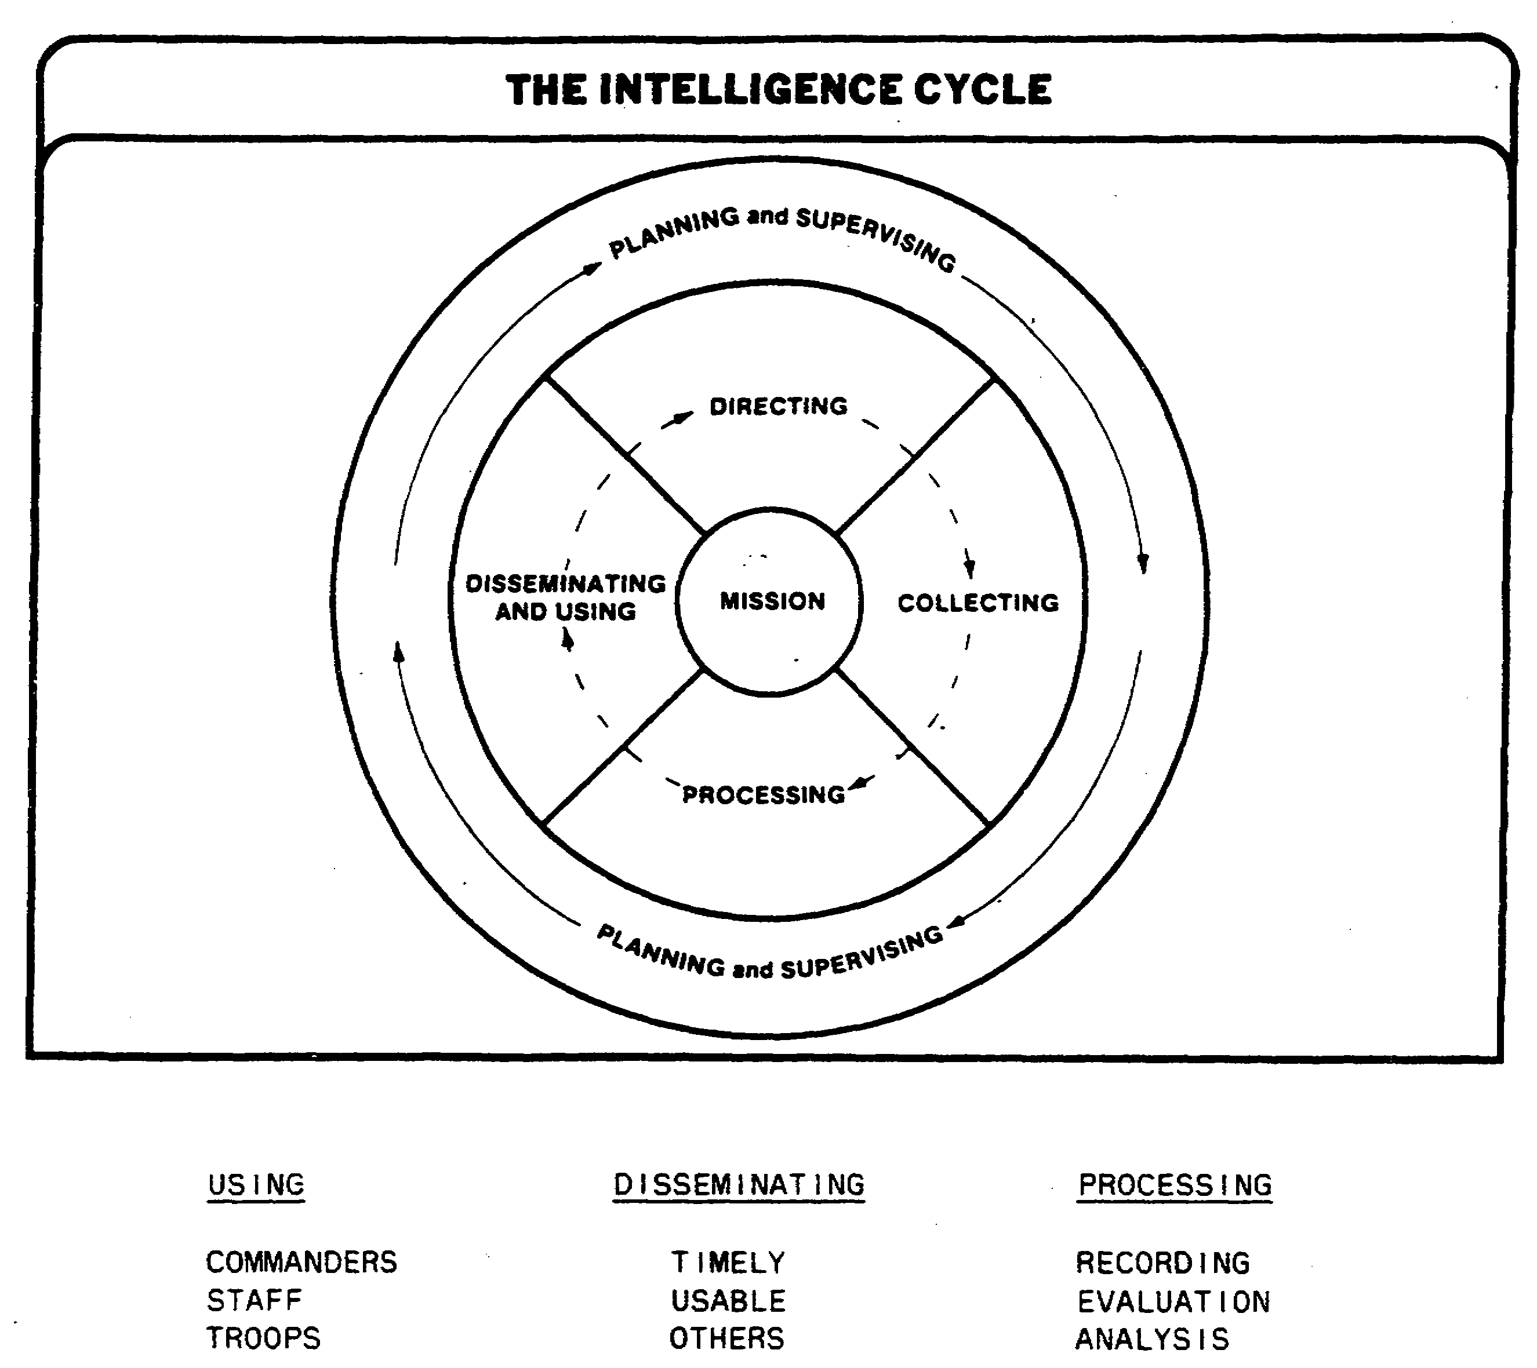

Figure 1-1. Four-Phase Intelligence Cycle.

3 IT 0648

(1) Recording is the reduction of information to writing or some other form of graphical representation and the arranging of this information into groups of related items.

(2) Evaluation is the determination of the pertinence of information to the operation, reliability of the sources or agency, and accuracy of the information.

(3) Analysis is the determination of the significance of the information relative to information and intelligence already known and drawing deductions about the probable meaning of the evaluated information. The imagery analyst (IA) will primarily contribute to this vital step by accurate interpretation, identification, and analysis of the imagery.

NOTE: The sequence for processing varies with the nature and- urgency of the information. Information is normally recorded first. However, if it contributes to the development of urgent intelligence, it may be recorded simultaneously with or after evaluation and analysis.

d. Phase 4: Disseminating and using is the last and most vital phase of the cycle. Usable information and intelligence are rapidly disseminated to those who need it without waiting for additional information or further processing. The completed intelligence product is disseminated through annexes, briefings, estimates, messages, reports, situation over-lays, and summaries. A useful intelligence product is one which will assist the commander and staff by providing a basis for evaluating and interpreting new information, while providing a further direction to a new cycle of intelligence operations.

3. Intelligence community.

a. Intelligence is usually categorized by the source of information--human, signal, or imagery. Each category contributes a unique portion of the total intelligence picture. Each is at least partially dependent on the others for cuing and to confirm, clarify, or refute collection information.

b. Imagery Intelligence (IMINT) is the product of imagery analysis. Imagery is derived from radar, infrared, and optical sensors. Imagery analysis is the examination of objects on film or on electronic display to identify objects and deduce their significance. Within the corps tactical operations center (CTOC) /division tactical operations center (DTOC), IAs assigned to the CM&D section work closely with intelligence analysts of the ASPS. Intelligence analysts collect and analyze information from many different sources to develop OB.

IT 0648 4

c. Through your detection of military activity and identification of equipment from imagery, you are providing assistance to the intelligence analyst in developing OB.

PART B: ORDER OF BATTLE ELEMENTS

1. OB is the identification, strength, command structure, and disposition of the personnel, units, and equipment of any military force. Complete OB data is not normally furnished to the commander. Instead, the commander is provided conclusions, estimates, or analysis of probable enemy courses of action based on collected OB information. In campaigns involving irregular force units, all such units as well as auxiliary and underground elements will be included.

2. The intelligence analyst must evaluate eight 08 elements to arrive at OB. IAs are most concerned with the first three.

a. Composition is the identification and organization of units. The intelligence analyst is concerned with the complete designation of a specific unit by name, number, type, relative size or strength, and subordinate units. Composition to the IA is using the equipment appearing on imagery as indicators of the type and size of the unit, such as a tank battalion or a reconnaissance company. This information will aid the intelligence analyst and alert yourself to the possibility that other pieces of equipment related to that type of unit are probably in the area.

b. Disposition is the location of enemy units and the way they are tactically deployed. It also includes the recent, current, and proposed movements of enemy units. Tactical deployment is the relative position of units with respect to one another or to the terrain.

c. Logistics deals with the enemy's ability to get resupplies. Logistics is closely associated with combat effectiveness. The IA can determine the enemy's supply routes, installations being used as depots, and the type of transportation in use, such as railroads or waterways.

d. Strength covers the description of a unit or force in terms of men, weapons, and equipment. Information concerning strength provides the commander with an indication of the enemy's capabilities, and assists the commander in determining probable courses of action or options open to enemy commanders.

e. Training status. Individual and unit training can significantly contribute to the combat effectiveness of any military organization. The thoroughness, degree, and quality of individual training received by the recruit, specialist, noncommissioned officer (NCO), and officer are major factors in determining the overall efficiency of an armed force.

5 IT 0648

f. Tactics in OB intelligence include tactical doctrine as well as tactics employed by specific units. Tactical doctrine refers to the enemy's accepted principles of organization and employment of forces for the conduct of operations in the offense and defense.

g. Combat effectiveness is a term used to describe the abilities and fighting quality of an enemy unit. It affects the capabilities of a unit or army and may be predicted by analyzing--

(1) Personnel strength.

(2) Amount and condition of weapons and equipment.

(3) Status of training.

(4) Efficiency of the officers and NCOs.

(5) Length of time a unit has been committed in combat.

(6) Traditions and past performance.

(7) Personality traits of the unit commander.

(8) Area in which committed.

(9) Morale, health, discipline, and political reliability.

(10) Status of technical and logistical support of the unit.

(11) Adequacy of military schooling at all levels.

(12) National characteristics of the people.

h. Miscellaneous data include various types of supporting information needed by an intelligence analyst to contribute to the development of the other OB elements. Miscellaneous data include basic intelligence that can be described as "know your enemy," such as:

(1) Personality files.

(2) Unit history.

(3) Information on uniforms and insignia.

(4) Use of code number and names to conceal true designations or affiliation of units, field post numbers, and vehicles.

(5) Capabilities and limitations of foreign weapons and equipment.

IT 0648 6

PART C: ORDER OF BATTLE REFERENCES, RECORDS, REPORTS, AND FILES

1. As you may have already determined, the first and most vital step in the process is accurate identification. An incorrect identification of a piece of equipment could lead to a wrong conclusion on the type of unit by the intelligence analyst and IA. To make accurate analysis of what is actually occurring on the ground and correctly identify items of equipment, you must know the enemy. You don't need to be an expert on the enemy, but you must know where to find the information when you need it.

2. References. The majority of the information you will need to know can be found in the OB references located in the ASPS section. Some of the OB references currently published are:

a. OB handbooks contain data including descriptions of a foreign nation's political structure, typical organizations of that nation's military establishment, tactical doctrine applicable to various types of military units, and other more technical data, such as the logistical system in use and the characteristics of weapons and equipment.

b. Installation handbooks contain complete information concerning military installations in every city of a country or area of interest.

c. Miscellaneous references are publications and periodicals prepared at departmental and area command levels. These references may deal specifically with OB or any and all phases of combat and strategic intelligence.

d. OB books, charts, and tables have the current intelligence on the composition and disposition of the military establishment of foreign nations. Unlike the OB handbooks, they contain established intelligence data on major identified units and the subordinate elements.

3. Appendix A consists of an extract from FM 100-2-3. It begins with a line and block chart of a Soviet front (page 58), continues with a tank army, combined arms army, new army corps, and focuses on a typical Soviet tank division (TD), a motorized rifle division (MRD), artillery division (Arty Div), and airborne division (Abn Div).

a. The charts continue with the structure of the divisions with personnel and equipment. To avoid repetition in the use of these charts, cross-referenced page numbers indicate the pages to consult for detailed breakdowns. Equipment lists are cumulative, although recapitulation tables for larger units may show the breakdown among subordinate units. Otherwise, you may determine the distribution of equipment by consulting cross-referenced tables for lower-level organizations. Furthermore, you should keep in mind that several units are common in either division.

b. Personnel and equipment charts. Refer to Appendix A. On these pages you will find a personnel and equipment chart for the main units

7 IT 0648

listed. This chart is designed to be used for your first step in determining the unit identification. This will keep you from thumbing through numerous pages trying to find every unit containing a certain piece of equipment. Across the left-hand column you will find the different types of equipment listed. The equipment is broken down into several major areas which should help in locating a certain piece of equipment. For example, you would not be looking in the radar area to find a 122rn howitzer D-30. In the top column you will find the 18 main units listed where they appear with a more detailed breakdown. To use these charts and tables, locate the item of equipment Identified from the imagery and follow that row of blocks across the page. Every time you come to a block containing a number, stop and go to the top to find which unit has that type of equipment. Continue this procedure until you have gone all the way across the column and note all the units containing that particular piece of equipment. The number that appears in the block represents the number of pieces of that type of equipment found in the unit listed on the top. The total number of each equipment is listed in the total to the far right.

(1) Example 1: How many units (by name) have 73mnm recoilless guns SPG-9? Going down the left-hand column, on page /1, you find it is the 14th piece of equipment In the weapons area. Going across the line, you find a 12 in the eighth block. Going to the top, you find the unit which contains 12 x 73mm recoilless guns SPG-9: the 2 x motorized rifle regiments (MRR)(BTR) of the MRD. There are no 73rrn recoilless guns SPG-9 in the ID, which is a clue the unit you are identifying can be traced only to a MRD.

(2) Example 2: You Identified 6 x tracked ferries GSP on imagery. Referring to the tables, you go down the left-hand column and find they are listed as the fourth piece of equipment (page 66) of engineer equipment. Going across that line you find there are 6 x tracked ferries GSP in the engineer battalion of a TD; this is also true for a MRD.

NOTE: You probably noticed the equipment in the TD is similar to the equipment in the MRD. To differentiate between the two, you should be looking for antitank (AT) guns, like the 100mm, T-12/MT-12, or 125mrrrn AT gun; there are 12 of these in the two MRRs (BMP) and none in the TD. Furthermore, if you should only identify one or two of the AT guns, you can identify that unit as part of a MRD: additional study of the imagery may reveal the other four AT guns.

NOTE: You will not always have to identify the exact number for the equipment contained in the units on the tables. Just find the ones that are fairly close to the numbers that are given.

4. Records and files are also kept so they can be consulted continually for the purpose of producing new intelligence. Files are established to catalog incoming information for easy reference and for use as a basis for

IT 0648 8

comparison and contrast in the production of new intelligence. 0B files should be simple, complete, and effective. One or more of these typical aids discussed may be employed; the type selected depends upon the existing situation and the echelon maintaining the files.

5. Unit workbook (Figure 1-2) consists of a collection of unit work sheets arranged by type of unit or in numerical sequence. Any information pertaining to a certain type of unit is listed on the appropriate work sheet. By combining a lot of information, the intelligence derived becomes clearer.

a. The intelligence analyst should maintain records and the unit workbook of enemy units one echelon above and two echelons below the unit of assignment.

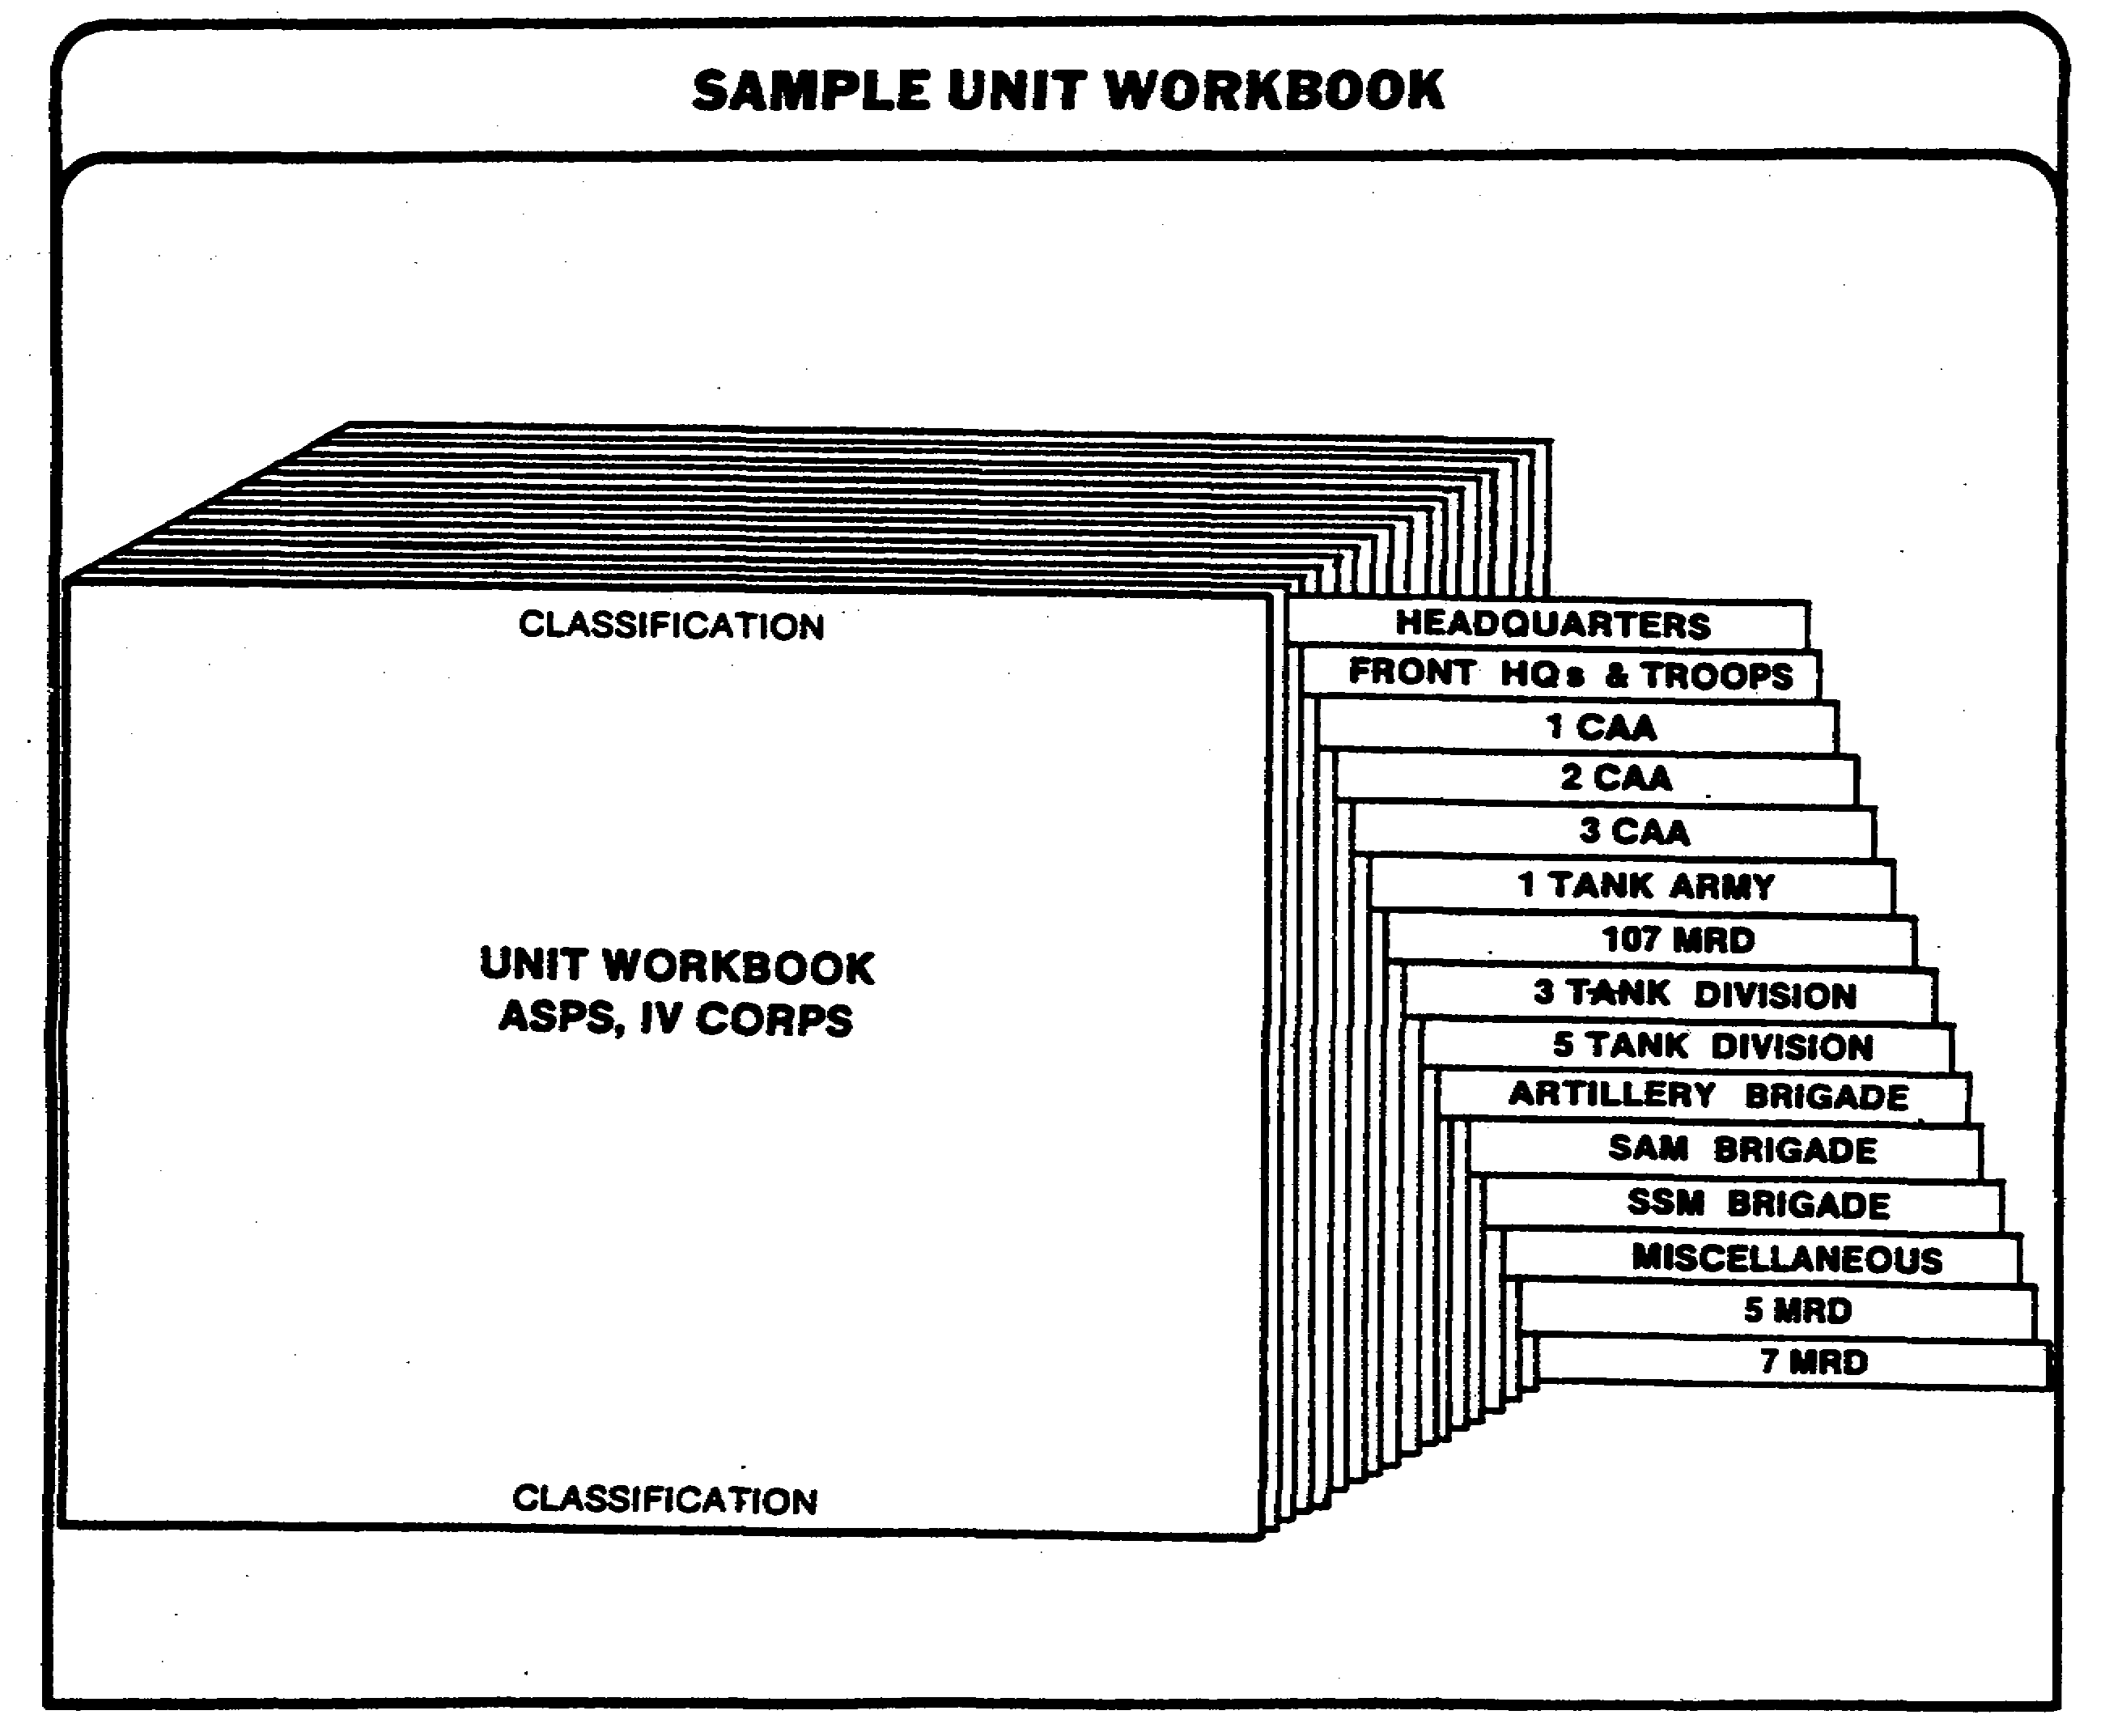

Figure 1-2. Unit Workbook.

9 IT 0648

b. Unit work sheet. The unit workbook consists of unit work sheets. All data collected on a particular unit are placed on individual work sheets (Figure 1-3). The work sheet will contain such items as: the name of the subordinate unit the information pertains to; its location by city, name, and coordinates; a numerical designation for the installation when it is accompanied by a sketch map, town plan, or map sheet; a listing of the key individuals assigned to that unit under the identification number (ID No) column; and, in the remarks column, any other OB information pertaining to that unit, to include the source of the information and the date acquired.

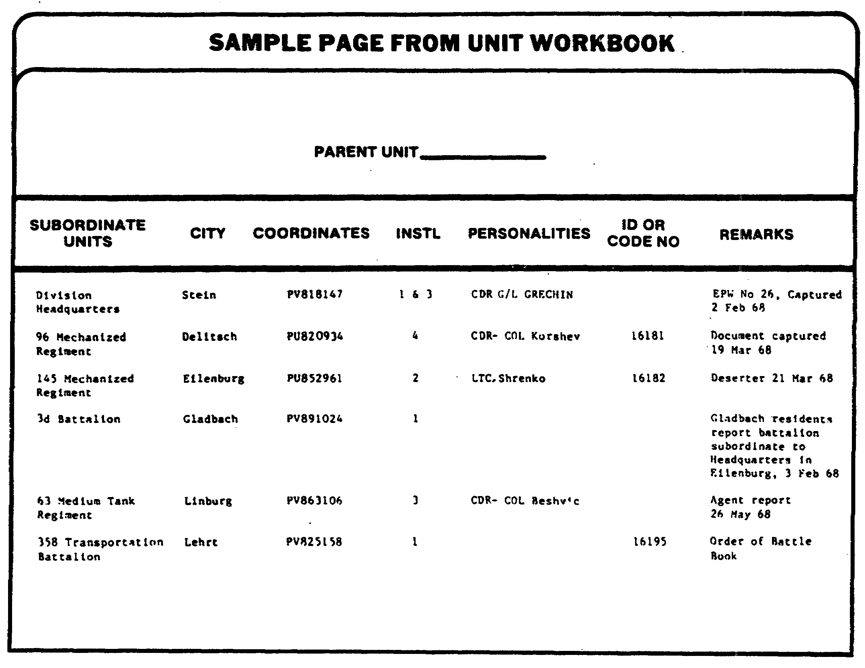

Figure 1-3. Unit Work Sheet.

IT 0648 10

6. OB workbook (Figure 1-4) aids in the sorting and Interpretation of information, and helps in the preparation of intelligence reports. Its purpose and use are identical to that of the intelligence workbook. There is no prescribed format for the OB workbook, but at corps and echelons above corps (EAC) it is tabbed to conform with the paragraphs of the OB annex of the periodic intelligence report (PERINTREP). Information is entered under the appropriate heading, as either a complete report or parts of a report. All entries contain a journal date and number as well as identification of the source.

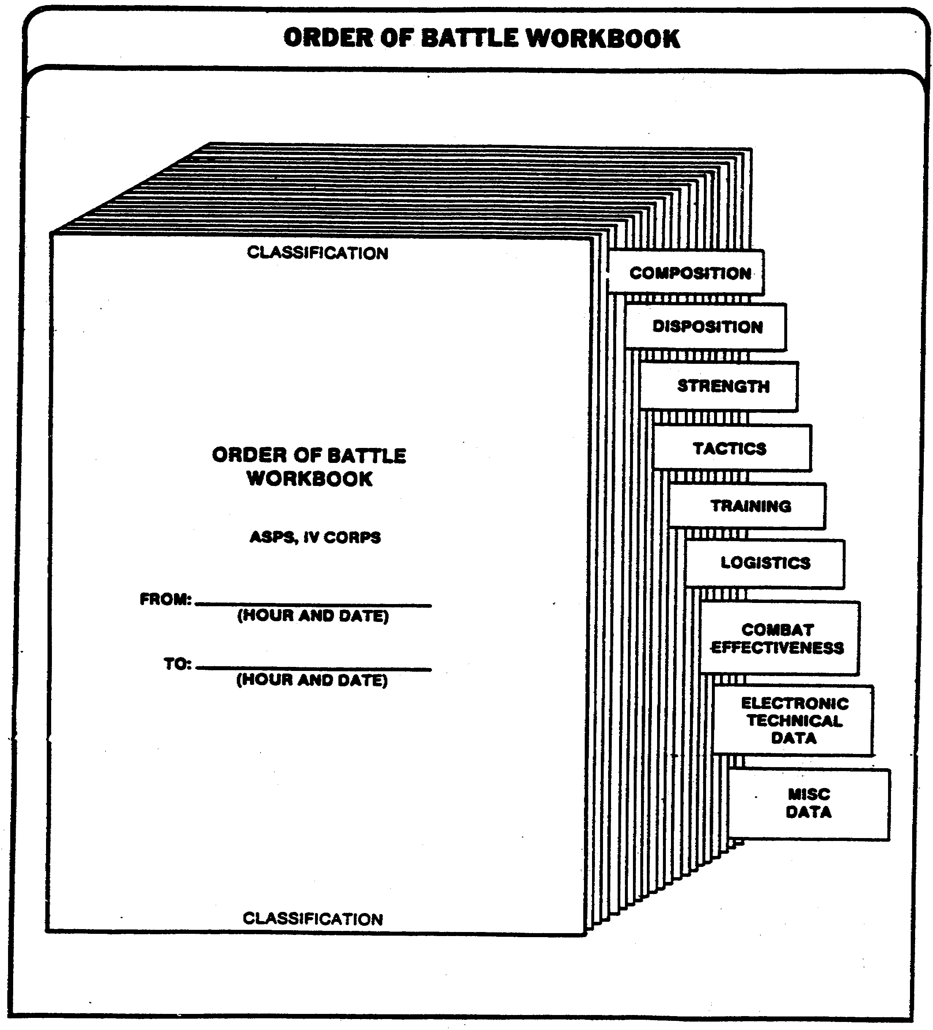

Figure 1-4. OB Workbook.

11 IT 0648

7. OB situation map (SITMAP) (Figure 1-5) is a graphic picture of current enemy OB, either confirmed or unconfirmed. It shows the unit's identification, location, and any other information which will assist in developing enemy OB. Strength, unlocated units, and a legend is added in a caption box which is attached to the SITMAP.

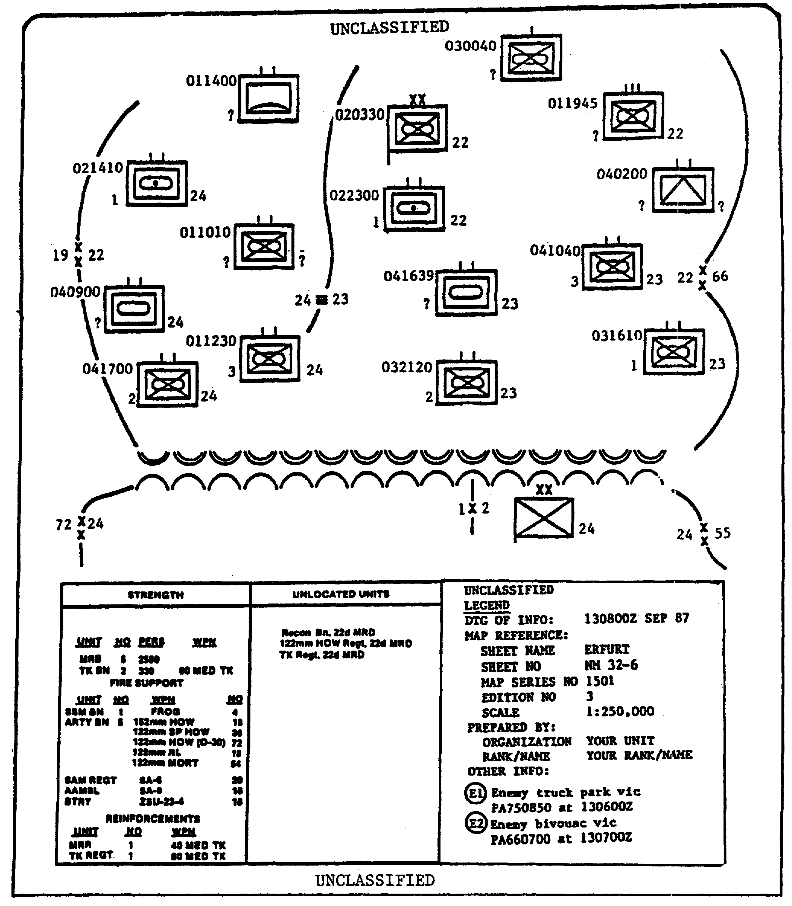

Figure 1-5. SITMAP.

IT 0648 12

a. The general rule is to plot enemy units one echelon higher and two echelons lower than the intelligence specialist's own unit, using the appropriate symbols listed in FM 101-5-1. Unit symbols are plotted center of mass and six fields are used to indicate unit size, type, identification, chain of command, supplemental information, and date time group (DTG) of information reported (Figure 1-6 and 1-7).

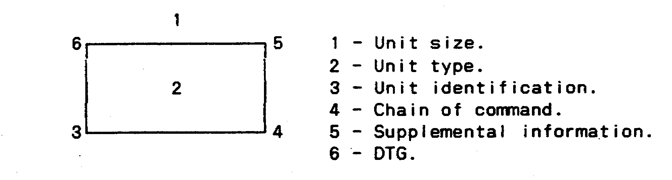

Figure 1-6. Typical Unit Symbol.

b. For example, the 3rd Howitzer Battery of an unidentified enemy Howitzer Battalion of the 16th Guard Regiment, sighted on the 5th day at 1200Z (Figure 1-7).



Figure 1-7. Typical Enemy Unit Symbol.

8. OB cards (Figure 1-8) are used to maintain accurate and complete data on any enemy unit. They should be maintained at all echelons down to and including division or such lower levels as may be necessary. Normally, one card will be maintained on each enemy division or any other unit in a position to affect current operations.

13 IT 0648

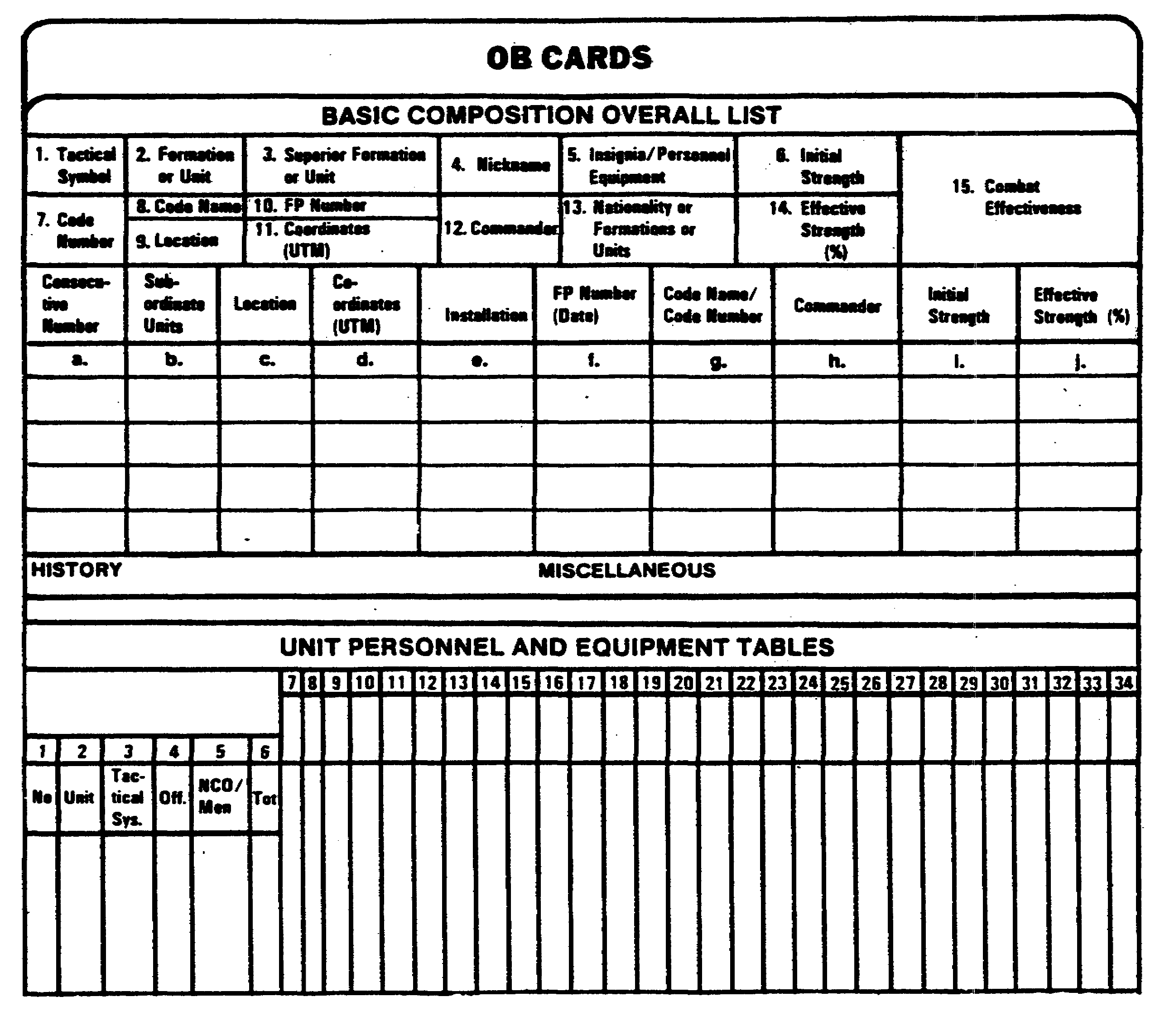

Figure 1-8. OB Cards.

IT 0648 14

9. Personality file's purpose is to provide reference material for use in the development of other OB intelligence. Information on key military figures can be of significant value in the establishment of unit identifications, tactics the unit might employ, and the combat effectiveness of that unit with these people in command positions. The card contains information concerning the individual's name, rank, current assignment, date and place of birth, civilian education, political affiliation, nick-names, and physical peculiarities. Reference is also made to schools attended, special qualifications, awards and decorations, engagements involved in, level of leadership at each assignment, important activities participated in, and personality traits (Figure 1-9).

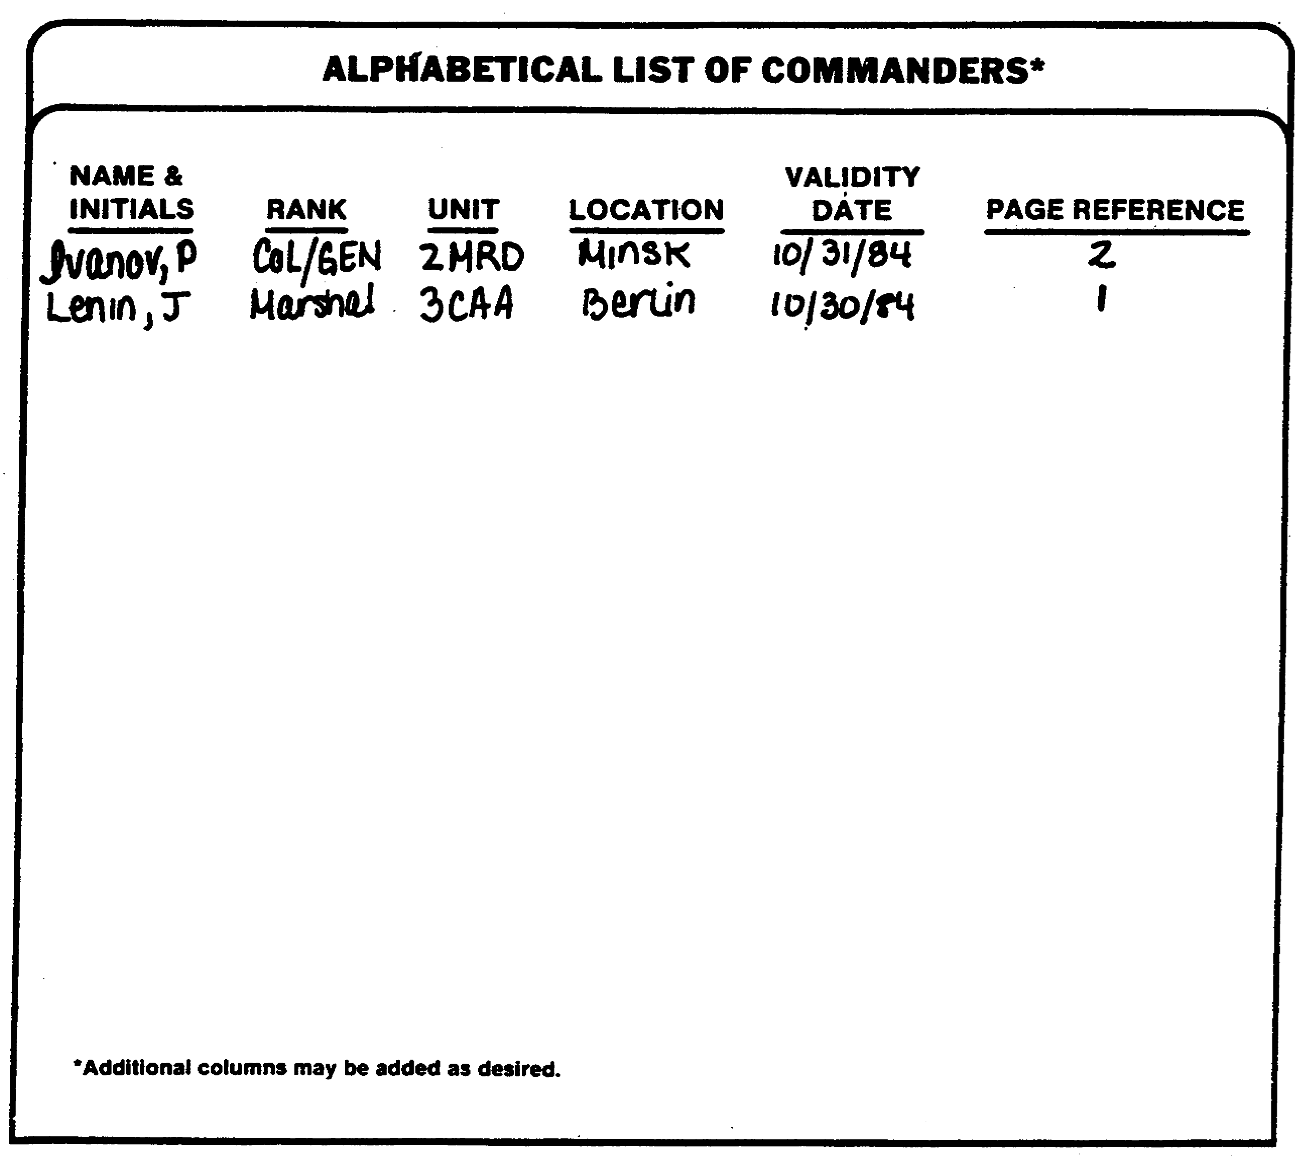

Figure 1-9. Personality File.

15 IT 0648

10. Military installation files (Figure 1-10) are normally maintained during peacetime by higher echelons to facilitate publication of installation handbooks. They consist of explanatory sheets which contain all the information collected on each installation to include the number and types of buildings and their capacities, personnel uniforms and insignia, and major items of unit equipment. Maps, town plans, or sketches showing the location of each installation within a city can accompany this file.

11. Organizational file provides a convenient method of showing types of units within an armed force. Organizational files show the complete breakdown of all units from the highest type headquarters to the lowest unit, including personnel and major weapons strength. Since this is rarely possible on a single sheet of paper:, a chart showing the general organization of the major unit and individual charts for each of its subordinate units are prepared. Principal weapons and equipment charts may be prepared to supplement organizational charts as shown in Figure 1-11.

12. Situation report. Operational situation reports (SITREPs)(Figure 1-12) are used to report information about the tactical situation or administrative information that may affect the tactical situation to higher authority. Although its preparation and dissemination is a staff responsibility of the CMO, the intelligence analyst or IA prepares or extracts paragraph 1, enemy.

13. Intelligence report (INTREP)(Figure 1-13) is a standardized report which is disseminated on an as-required basis. It is prepared when facts influencing the enemy capabilities have been observed or when a change in enemy capabilities has occurred.

a. Any commander can direct that an INTREP be prepared. It is passed to higher, lower, and adjacent units at the discretion of the commander producing the report; the intelligence analyst/IA, at these units, will extract OB information from INTREPs as deemed necessary.

b. The INTREP is dispatched as quickly as possible after receiving pertinent information or intelligence and sent by the quickest possible means. There is no prescribed format for the INTREP except that the acronym "INTREP" must be the first item to appear in the report. For joint service operations, however, INTREPs will use the standard Joint Chiefs of Staff (JCS) format in Figure 1-14. If there is enough time, the INTREP also includes the originating office's interpretation of the information or intelligence being reported.

IT 0648 16

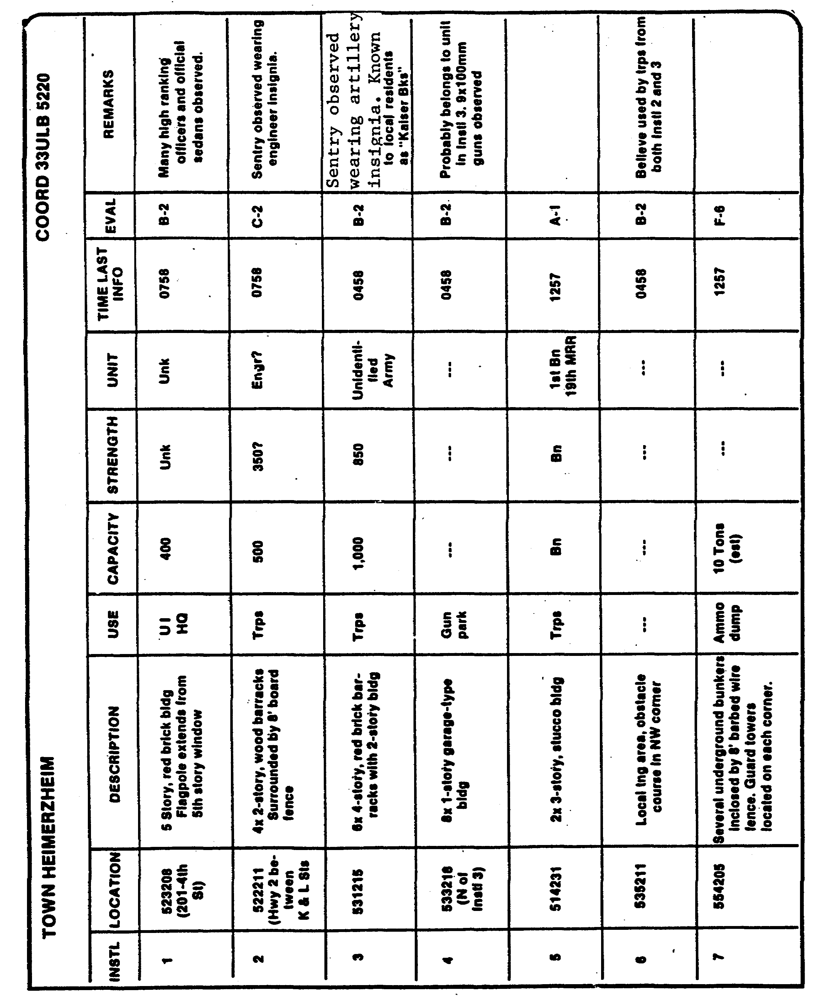

Figure 1-10. Military Installation File.

17 IT 0648

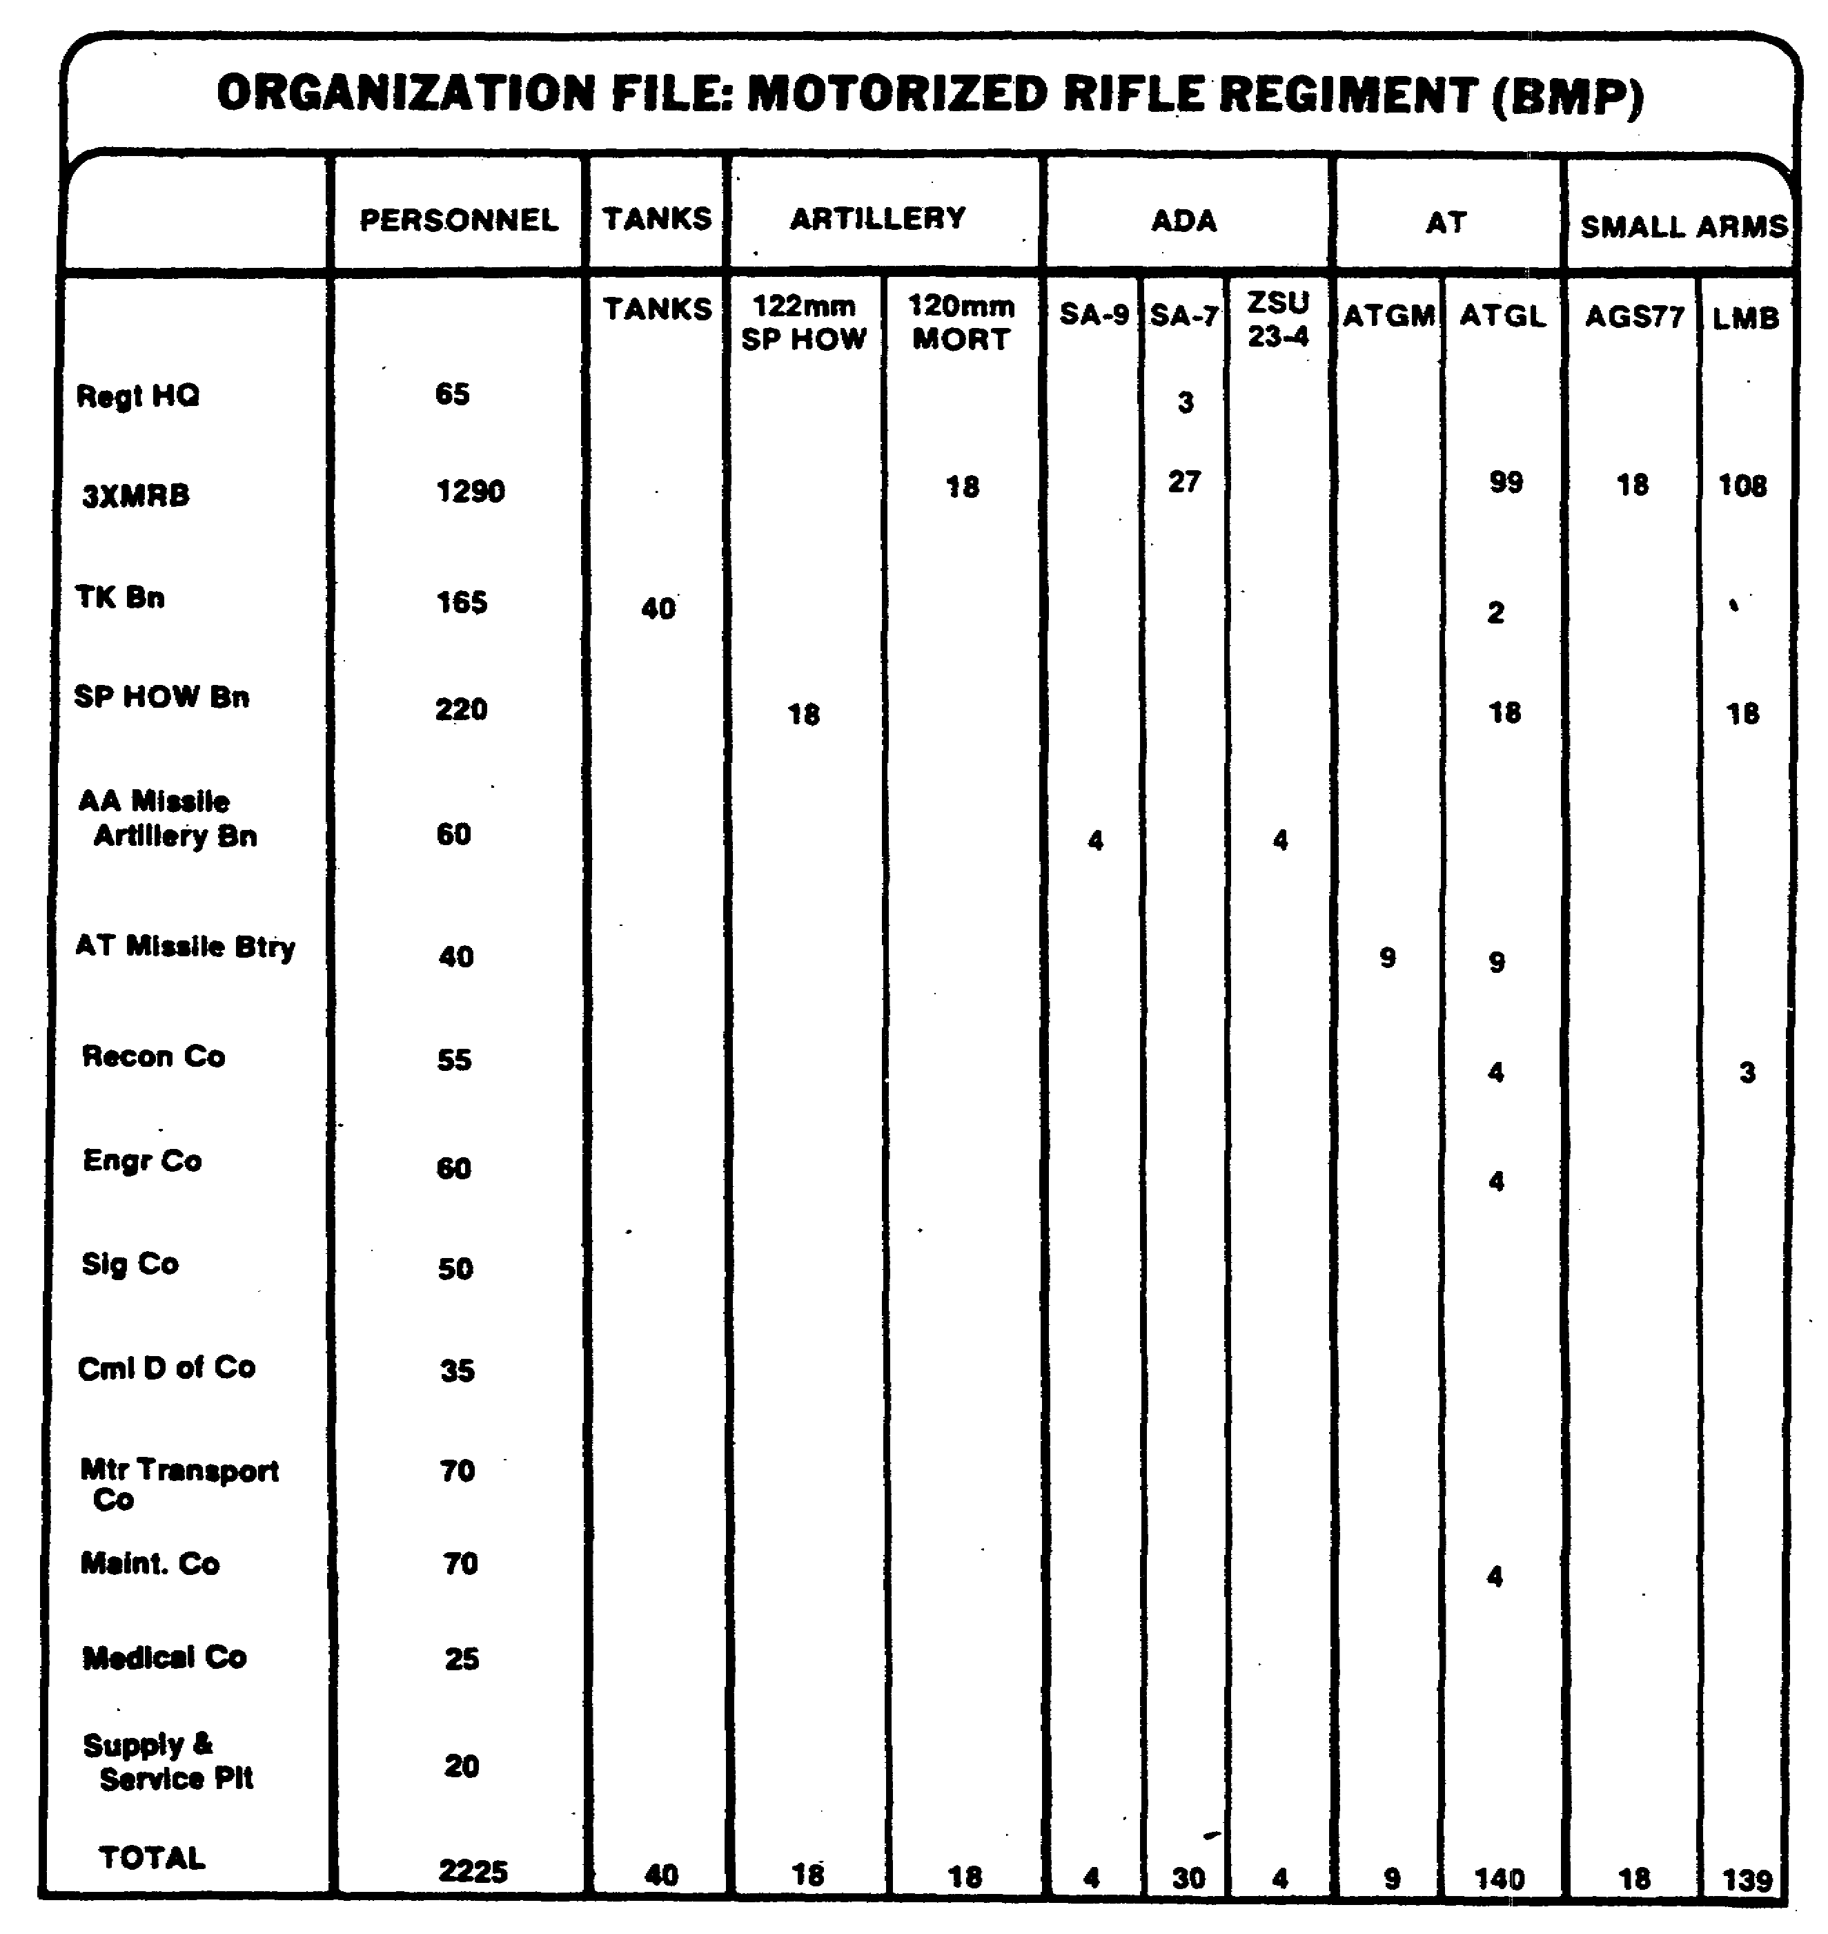

Figure 1-11. Organization File.

IT 0648 18

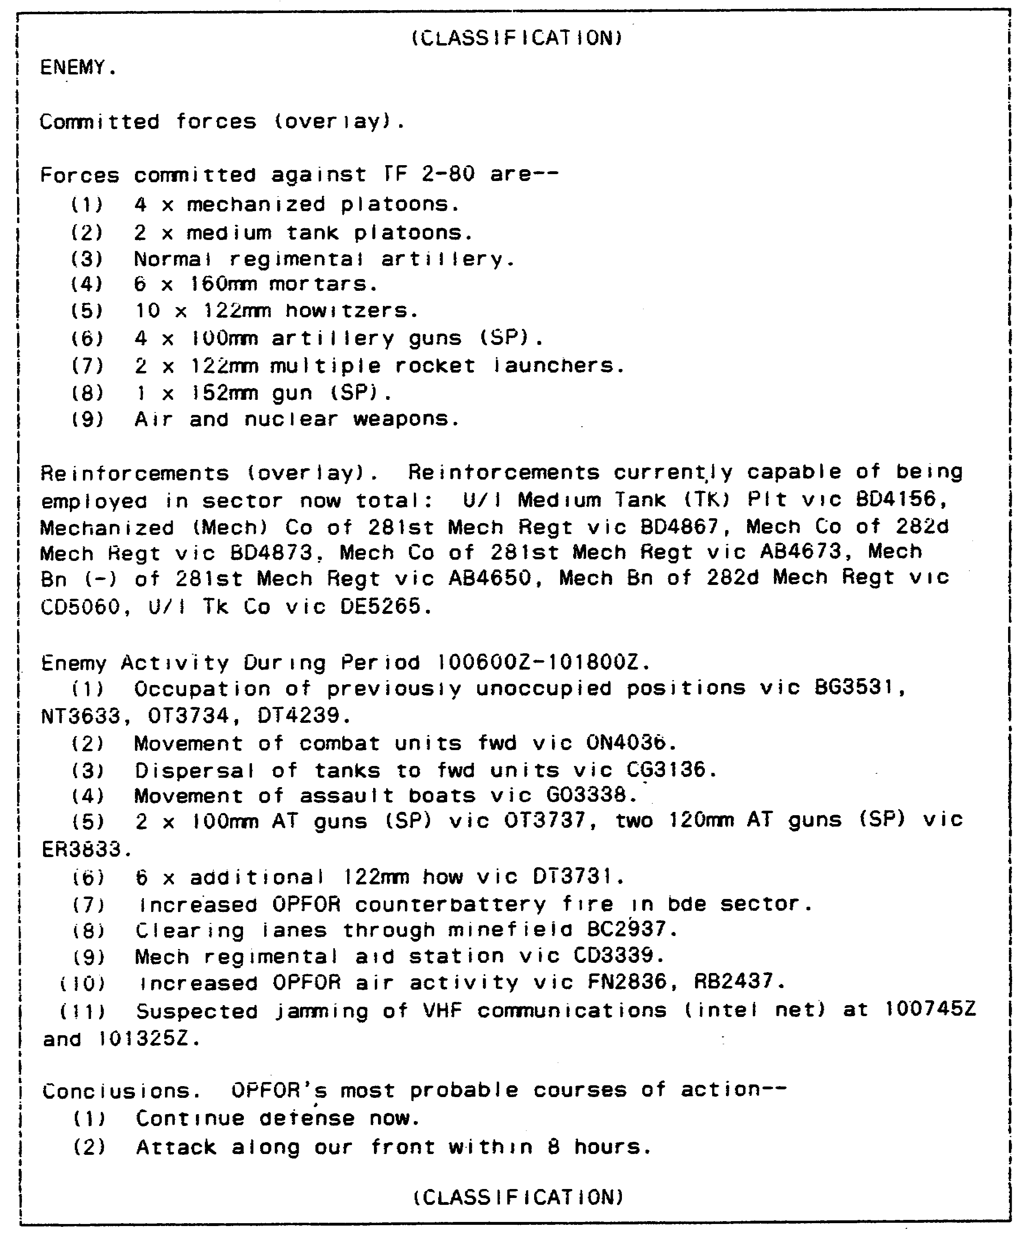

Figure 1-12. SITREP.

19 IT 0648

INTELLIGENCE REPORT

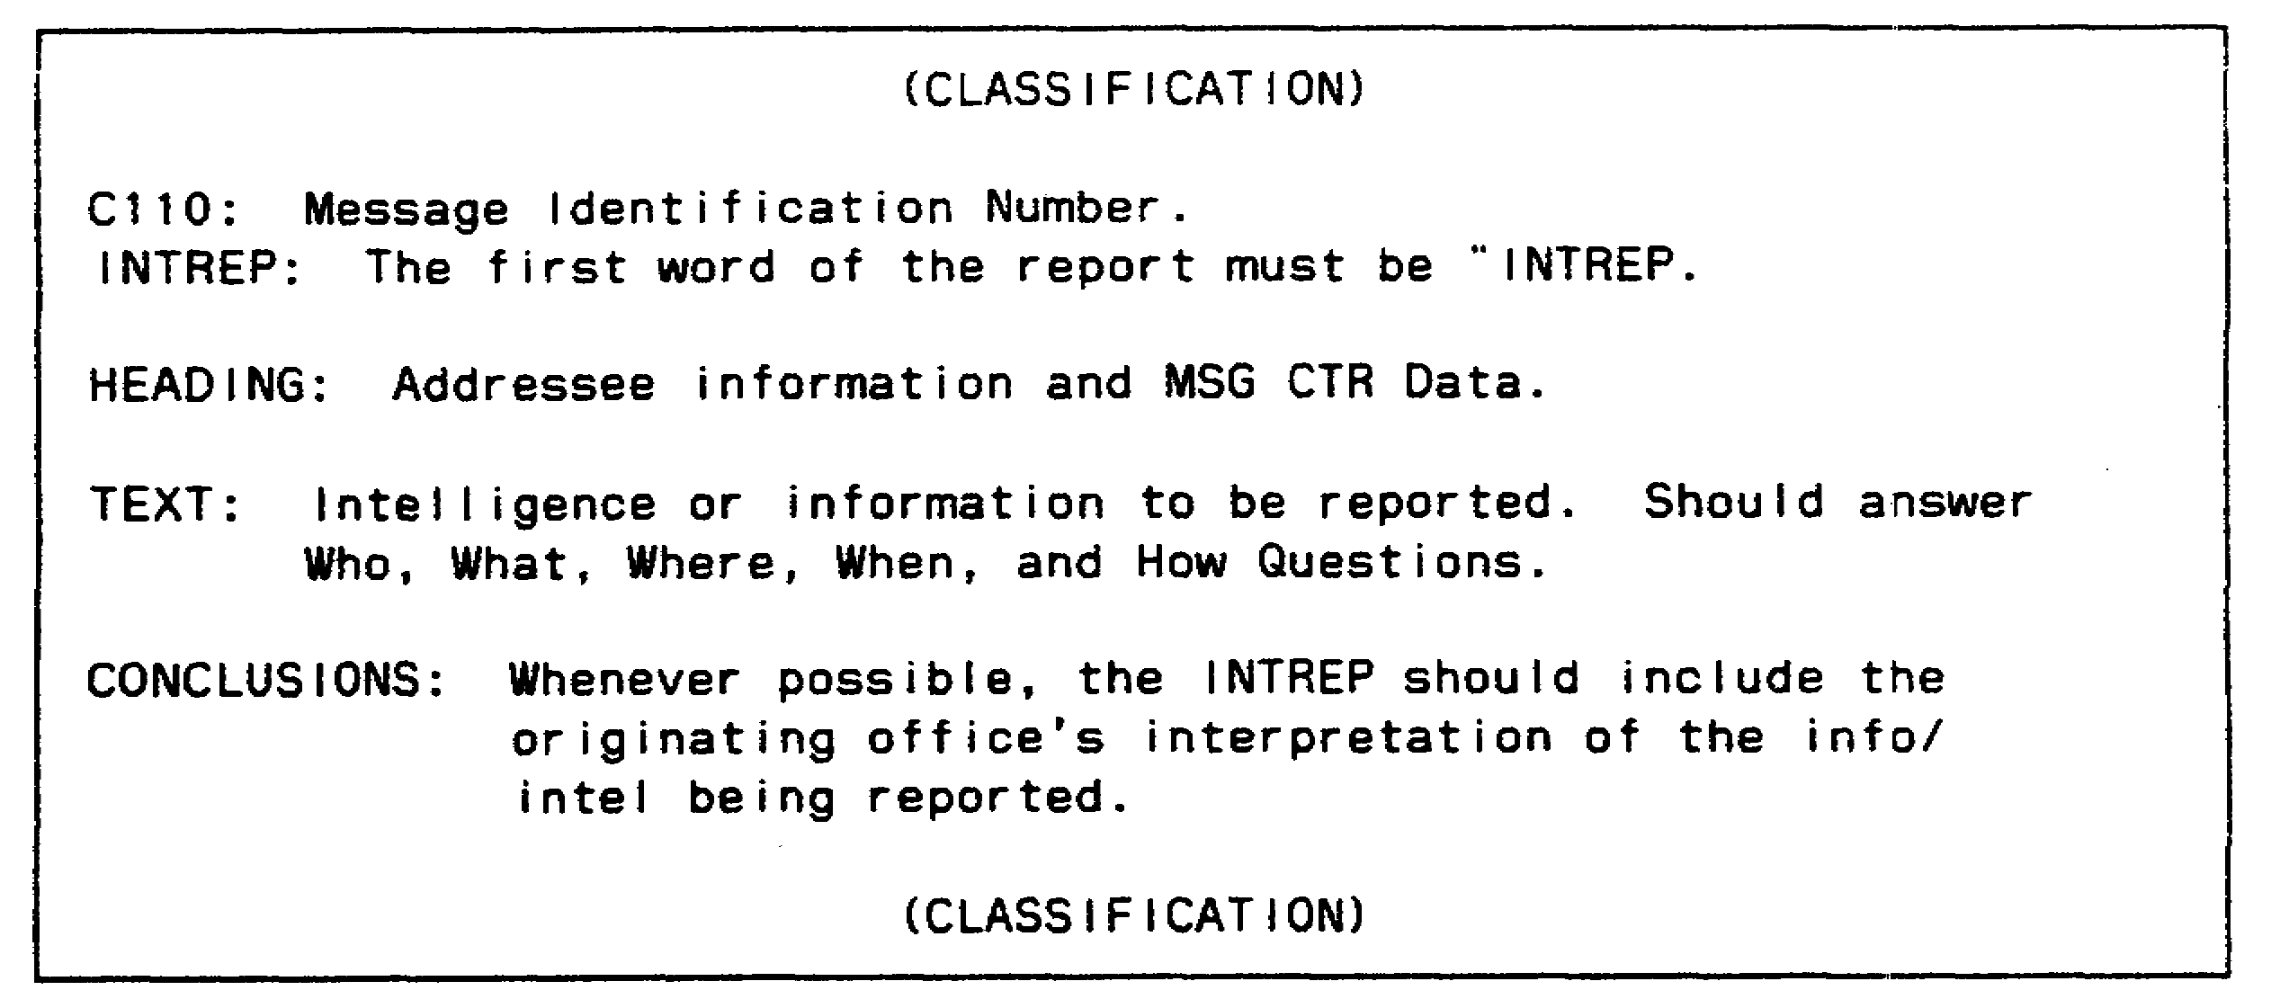

Figure 1-13. INTREP Message Format.

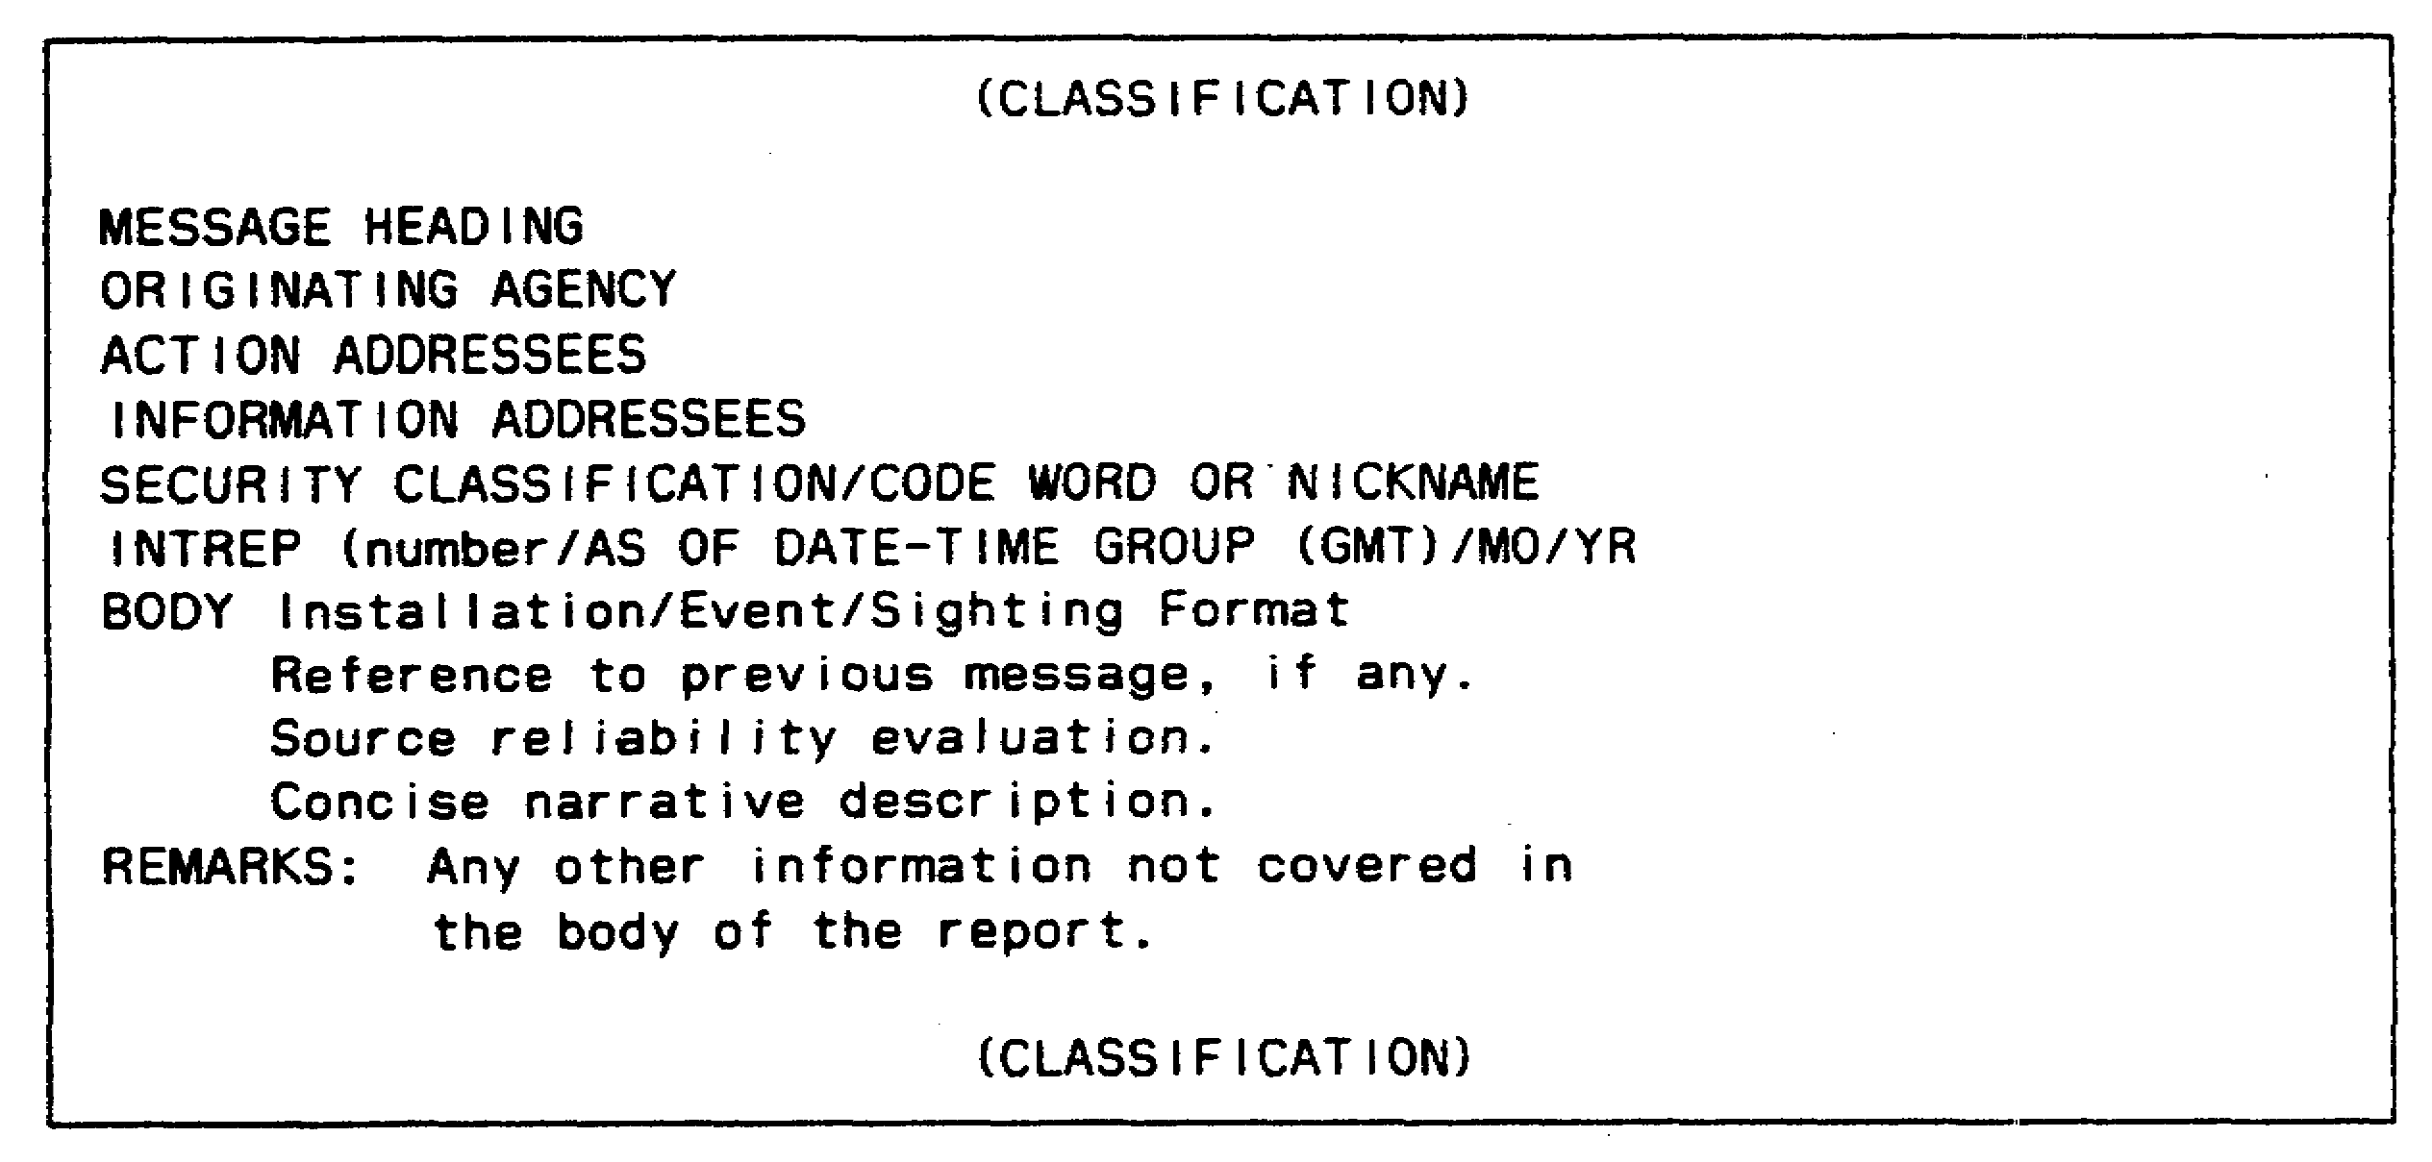

Figure 1-14. JCS INTREP Message Format.

IT 0648 20

14. Intelligence summary (INTSUM) is a brief summary of intelligence which is gathered over a specified period of time as stated in the unit SOP. This intelligence is of particular interest to the commanders who receive it. It provides a summary of the enemy situation and assists the intelligence analyst/IA in updating other intelligence reports. Negative information may be included in the INTSUM. This report reflects the interpretation and conclusions of analysts about enemy capabilities and probable courses of action.

a. The INTSUM is normally prepared at-brigade and higher echelons and is disseminated to higher, lower, and adjacent units. It has no prescribed format except that the acronym "INTSUM" must be the first word in the report (Appendix B). However, when involved in joint service operations, the format contained in Appendices C and D should be used.

b. Nonessential details should be excluded from the INTSUM, but information concerning the issuing unit, the date-time group of issue, a brief discussion of enemy capabilities and vulnerabilities, and conclusions should always be included.

15. Supplementary intelligence report (SUPINTREP) is in a NATO-standardized report format and is used for more comprehensive reviews. It contains information on one or several specific intelligence targets and follows the INTSUM format. It may also contain selected intelligence data collected over an extended period of time and includes items contained in the INTREP or INTSUM. The nature and content of the data contained in the SUPINTREP dictate the specific dissemination requirements. At the commander's discretion, the SUPINTREP is passed to higher, lower, or adjacent units. It is normally produced by special request or to support a particular operation is dispatched by the most suitable means available.

16. Periodic intelligence report (PERINTREP) (Appendix E) is a summary of the intelligence situation for a specified period in a tactical situation, normally 24 hours. The PERINTREP reports detailed information and intelligence. It covers the enemy situation, operations, capabilities, and vulnerabilities, characteristics of the AO, and CI.

a. Other intelligence documents like technical intelligence (TI) summaries, intelligence interrogation reports, translations of captured documents, and weather and climatic summaries may be disseminated as annexes to the PERINTREP.

b. The PERINTREP is concise, but complete, and makes maximum use of sketches, overlays, and annotated maps. Abbreviations and unnecessary references to map coordinates are avoided.

c. The PERINTREP normally is prepared at corps and EACs. Corps may dispense with the PERINTREP if the situation does not permit timely dissemination. Dissemination is always made by the most suitable means

21 IT 0648

available, usually by liaison officers or by messenger to the staff, adjacent units, and subordinate and higher headquarters at the next two higher and lower echelons. The PERINTREP should be disseminated in time for use in daily planning. In joint service operations, the PERINTREP is replaced by the PERINTSUM, using the same format.

17. Weekly intelligence summary follows the format of a PERINTREP (or the PERINTSUM in joint service operations). It highlights trends that are useful in planning future operations and in processing current information. This report normally is prepared at EACs.

18. Interrogation and translation reports (Figure 1-15) summarize the results of interrogation of EPWs, civilian detainees, or refugees, and translations or summaries of enemy documents. Information of immediate value is disseminated in spot reports. Other information is disseminated in the most suitable form for the users. At corps and EACs detailed interrogation and translation reports usually are distributed as annexes to the PERINTREP or the PERINTSUM in joint service operations.

19. Bombing, shelling, and mortaring reports. Bombing reports (BOMREPs), shelling reports (SHELREPs), or mortaring reports (MORTREPs) provide information on enemy bombing, shelling, or mortaring activity. The affected unit prepares and disseminates the reports. The affected unit's fire support officer (FSO) gets copies of these reports for input to the counterfire element of the force artillery TOC. Reports are rendered as normal messages and transmitted by the fastest means available. Each transmission is preceded by the acronym "SHELREP" in the case of enemy artillery, by "BOMREP" in the case of an enemy air attack, or "MORTREP" in the case of enemy mortar activity. The text of the message is transmitted in the clear except that the current call sign of the unit of origin is used rather than the unit identification. Also, the position of the observer is encrypted if it discloses the location of a headquarters or an important observation post. Appendix F contains the format for the BOMREP, SHELREP, or MORTREP.

20. Spot report. (Figure 1-16). The SALUTE mnemonic (formula) requires users to report enemy size, activity, location, unit, time, and equipment.

21. Meaconing, intrusion, jamming, interference feeder (MIJIFEEDER) report is used to report MIJI incidents to the communications-electronics (C-E) officer (Figure 1-17).

22. The mission report (MISREP) is used by all air units to report the results of air missions and visual sightings. It may amplify an inflight report (INFLIGHTREP) and provides data for postflight debriefings (Figure 1-18).

23. The INFLIGHTREP is used by pilots/air crews to report mission results or any other tactical information sighted of such importance and urgency that the delay, if reported by normal debriefing, would negate the usefulness of the information (Figure 1-19).

IT 0648 22

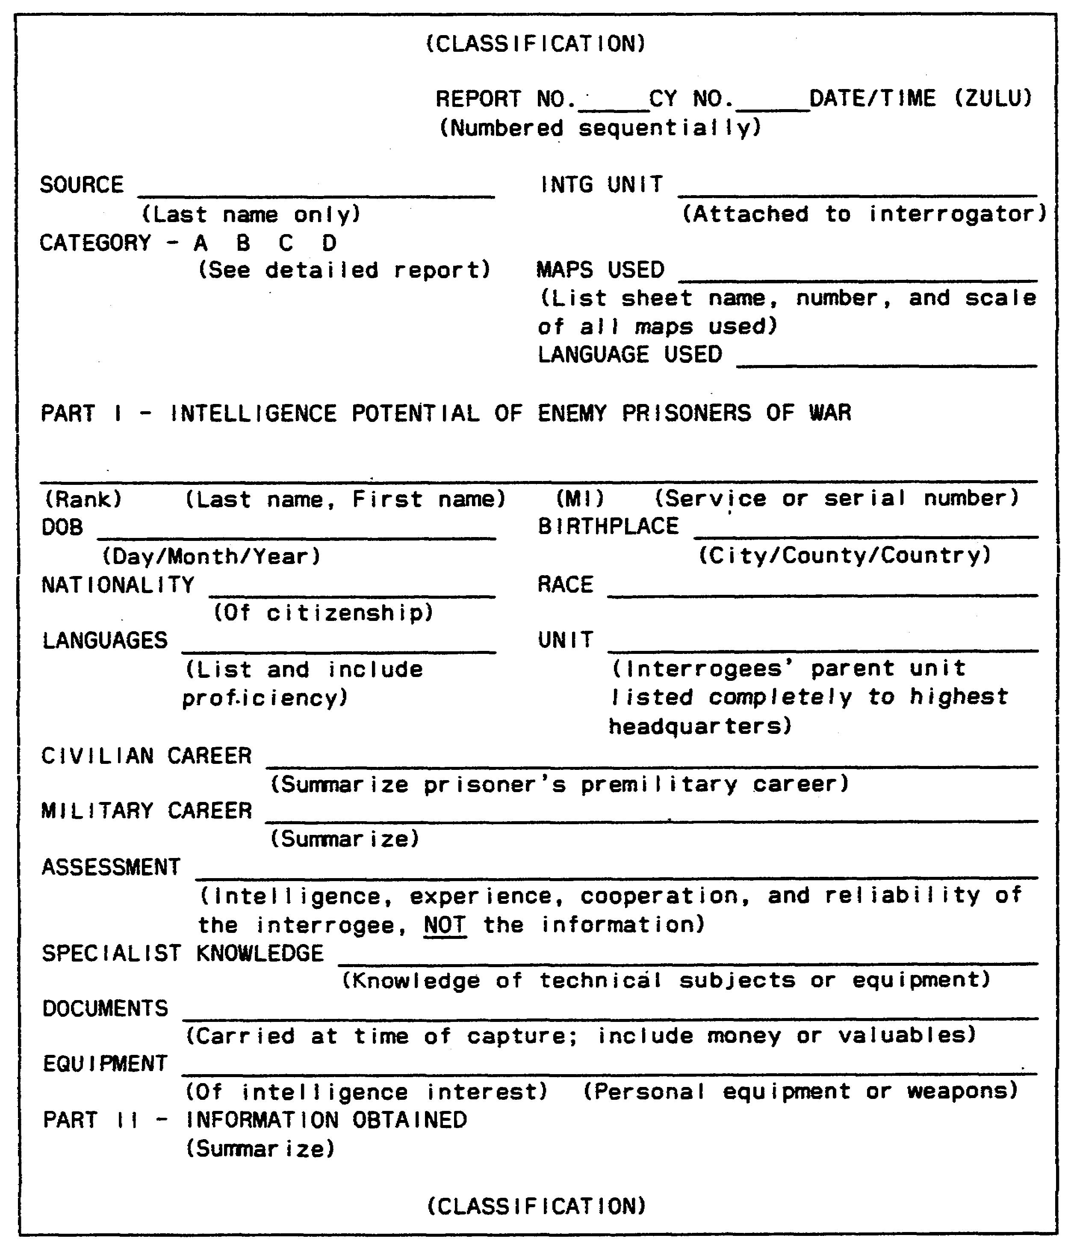

Figure 1-15. Initial Interrogation Report.

23 IT 0648

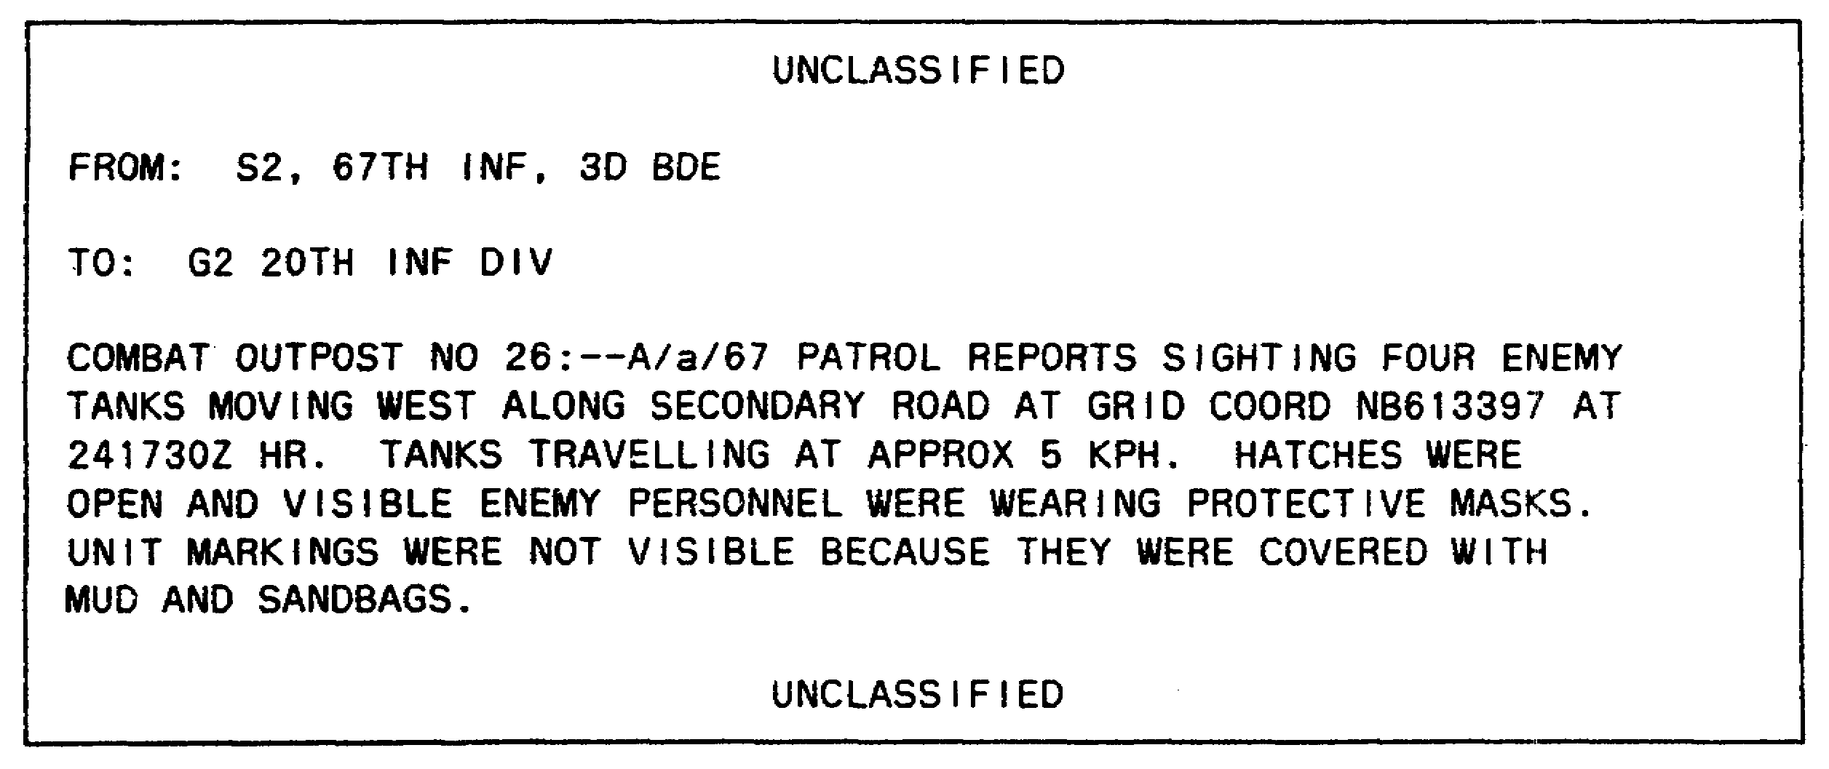

Figure 1-16. Spot Report Using SALUTE Message Format.

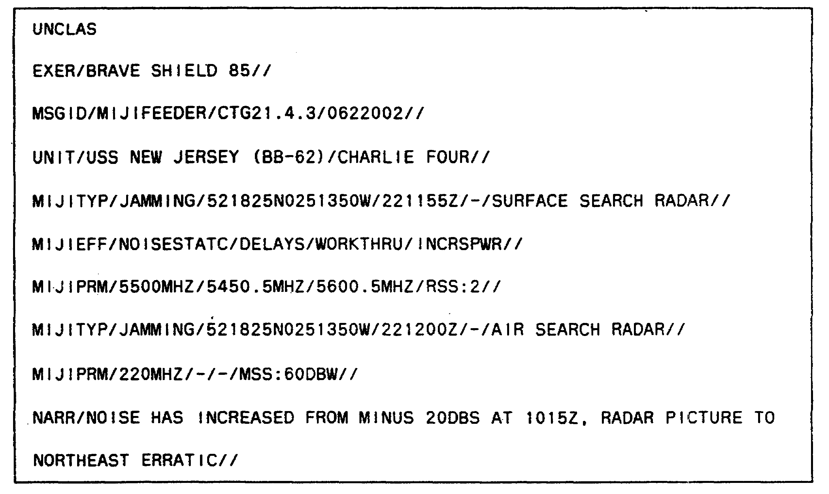

Figure 1-17. MIJIFEEDER Report.

IT 0648 24

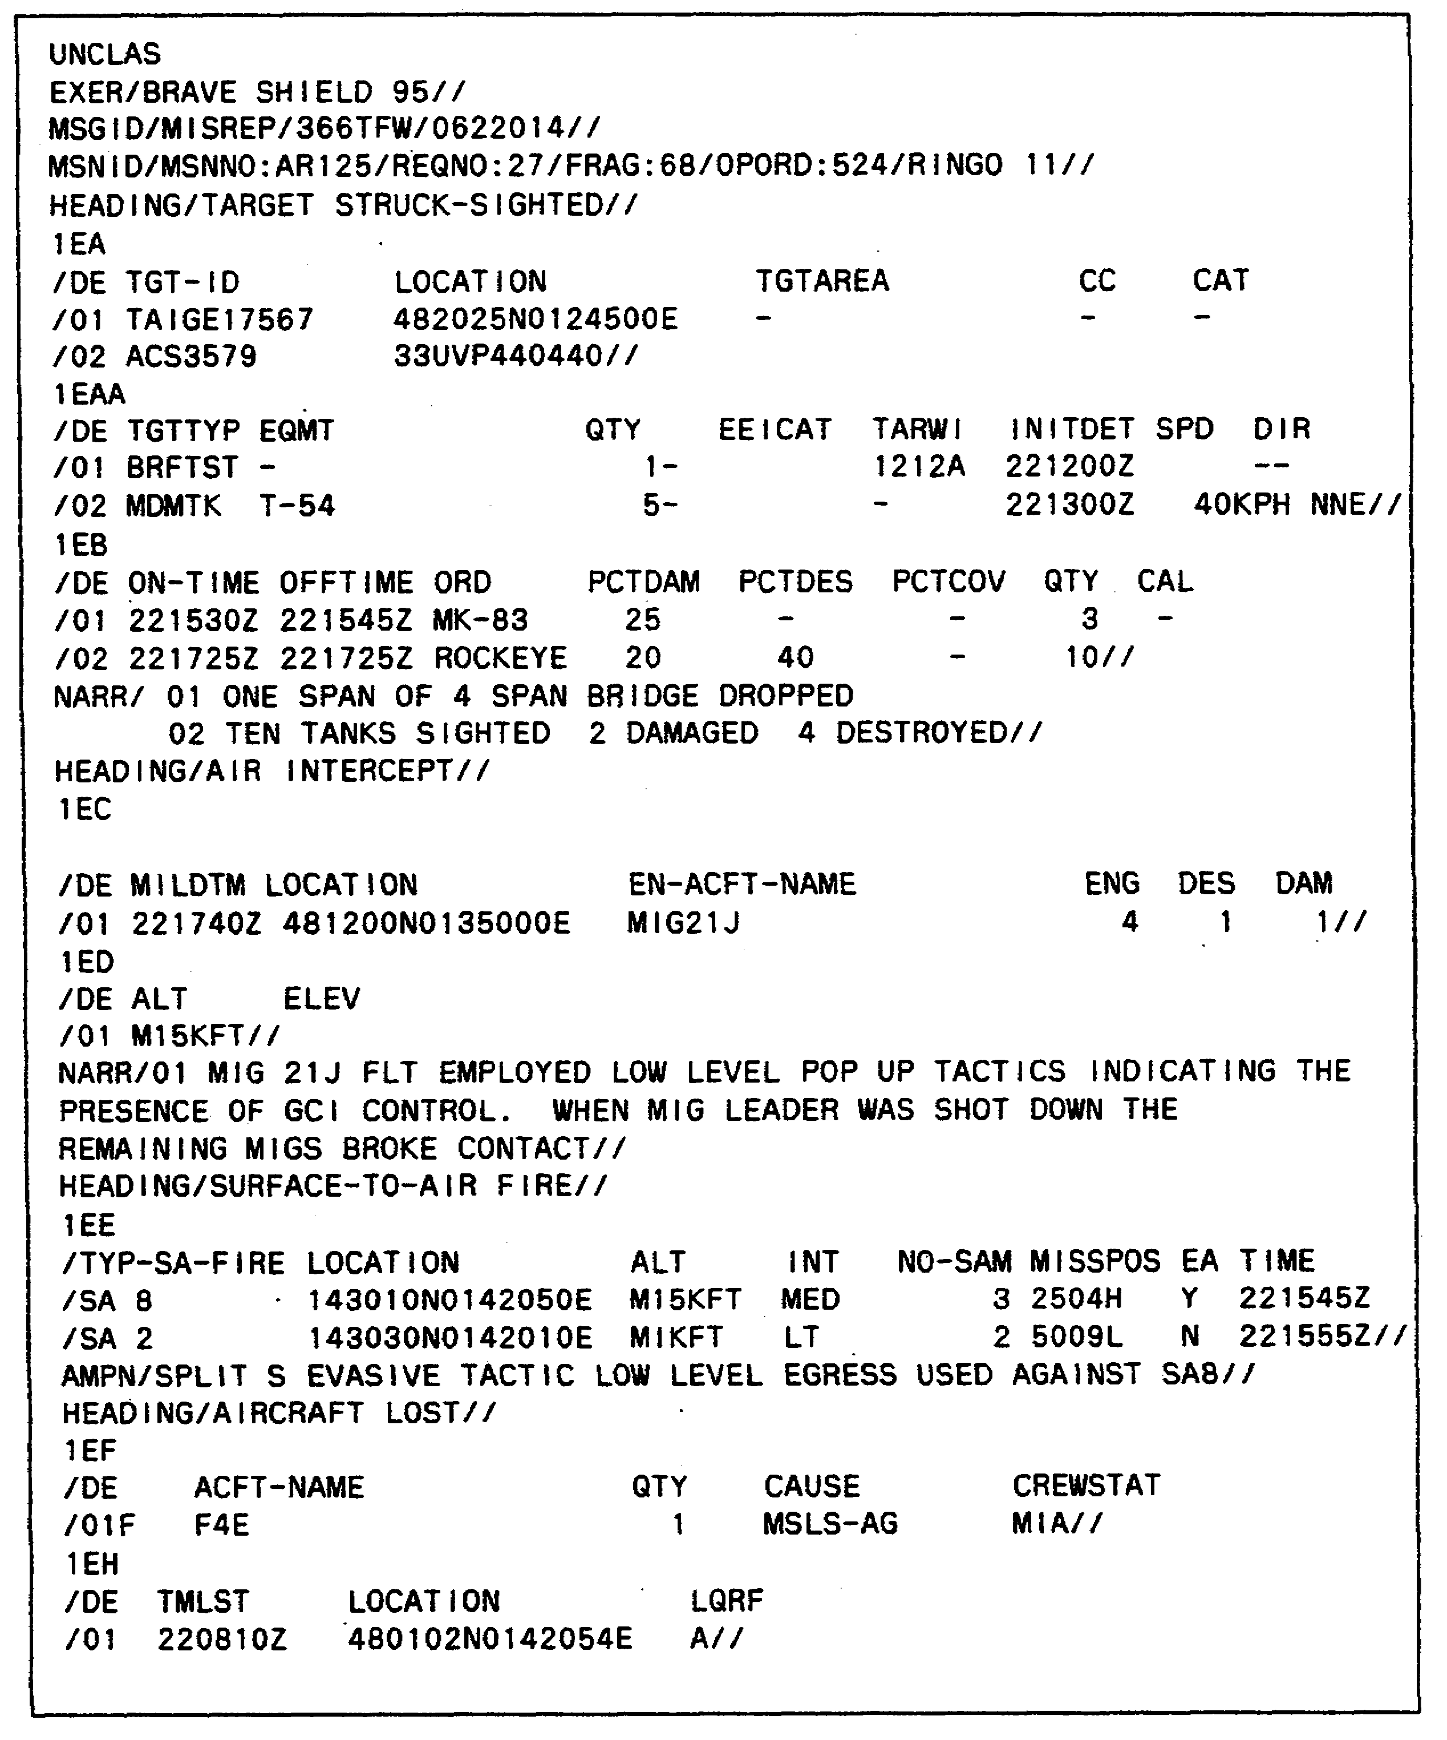

Figure 1-18. MISREP

25 IT 0648

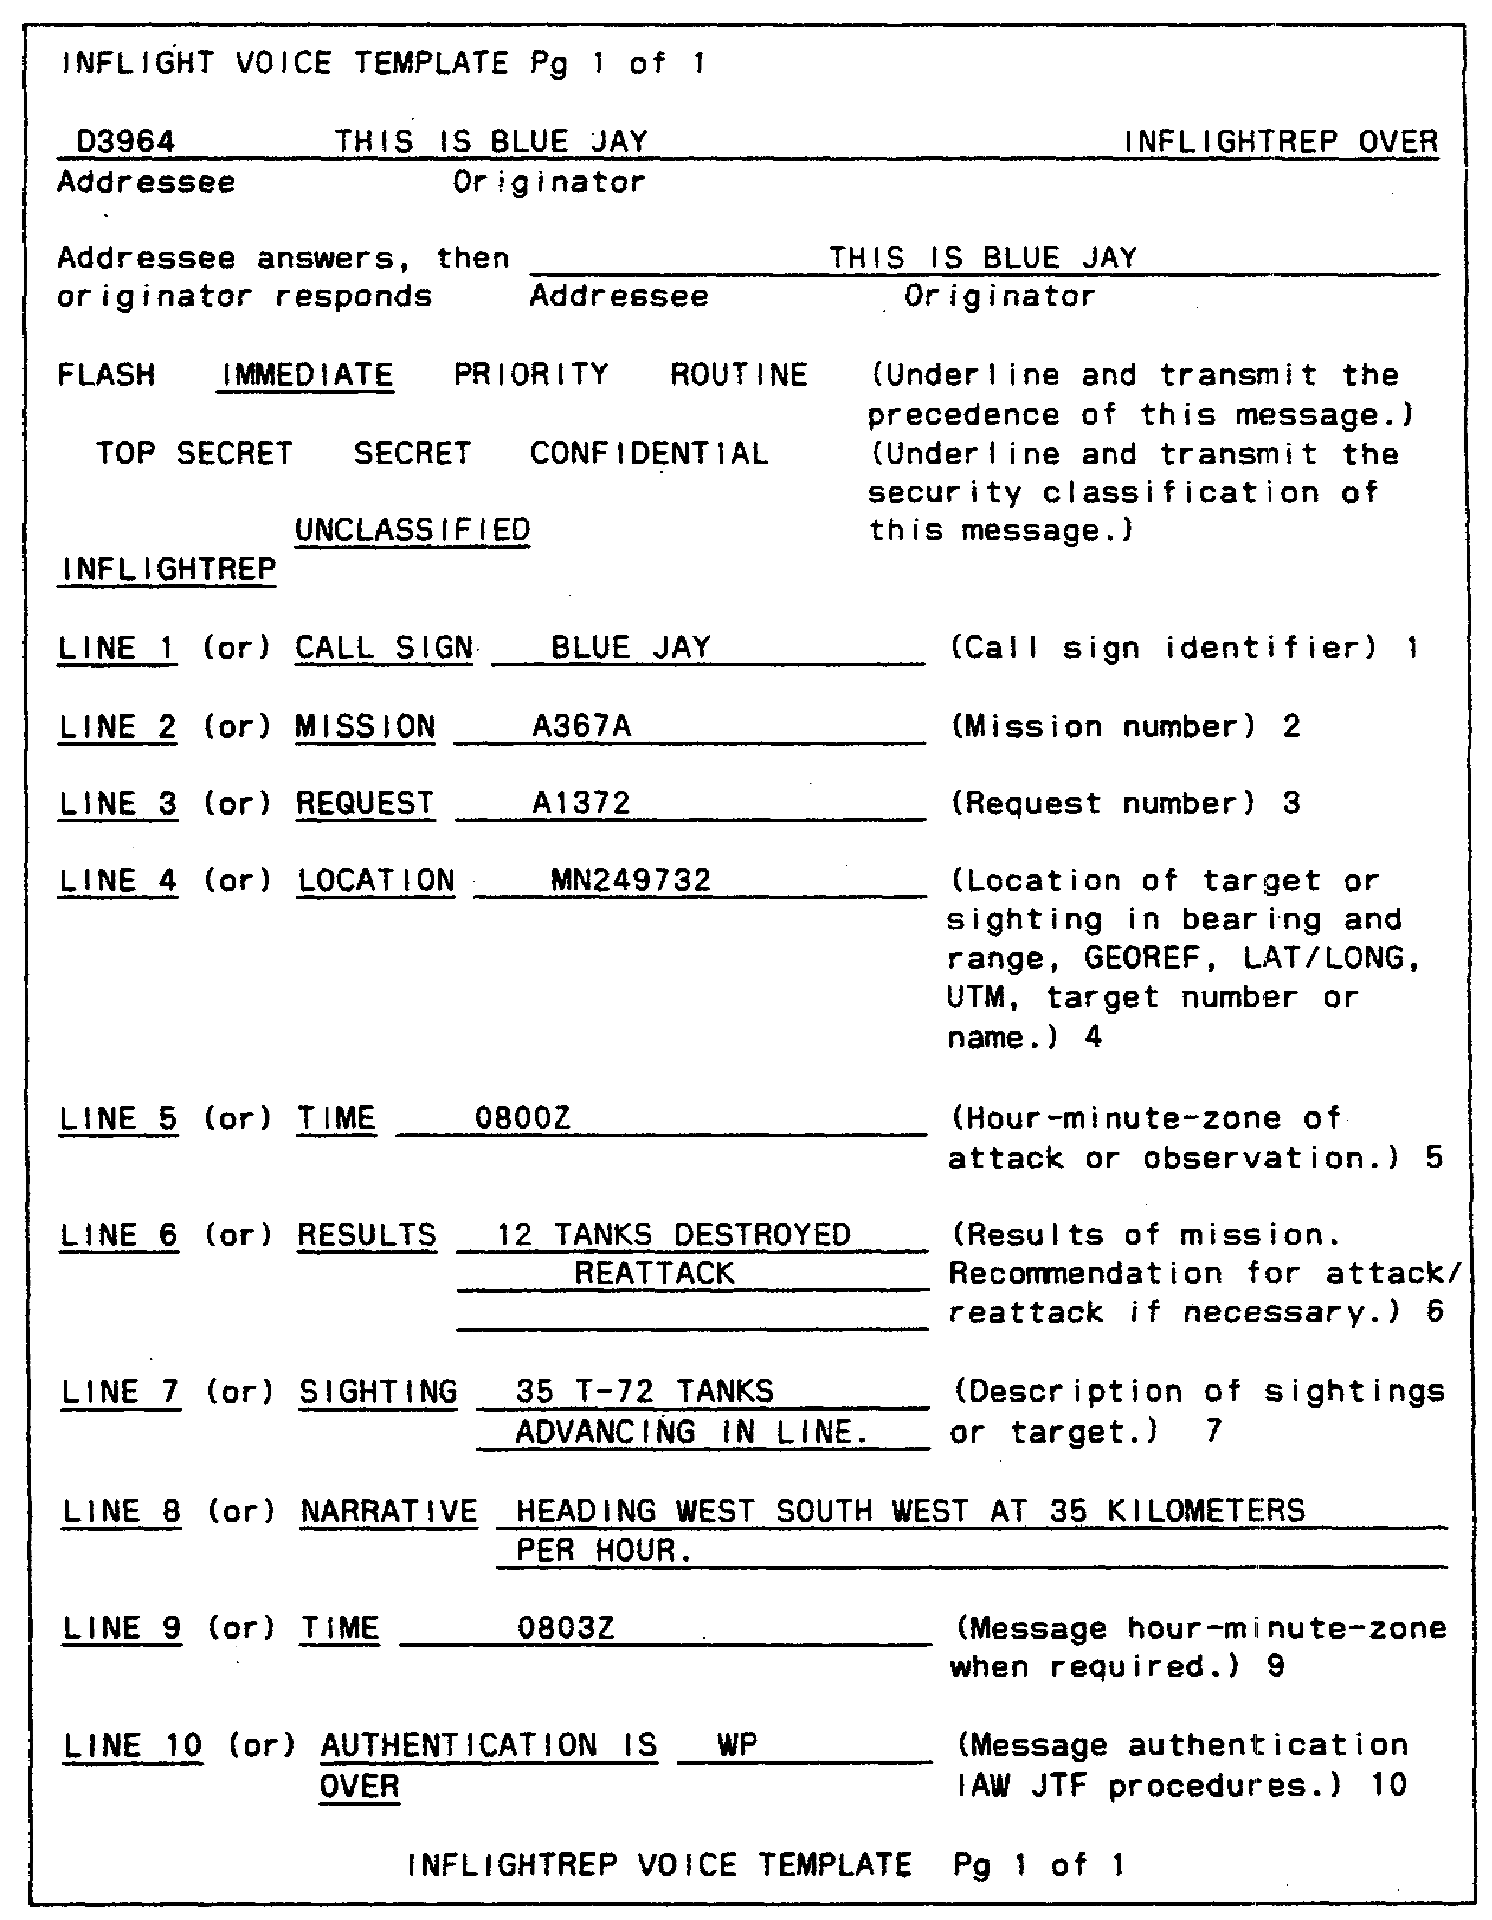

Figure 1-19. INFLIGHTREP.

IT 0648 26

24. The intelligence file worksheet serves to isolate problem areas and formulates relationships between items of information and intelligence items collected (Figure 1-20).

(CLASSIFICATION)

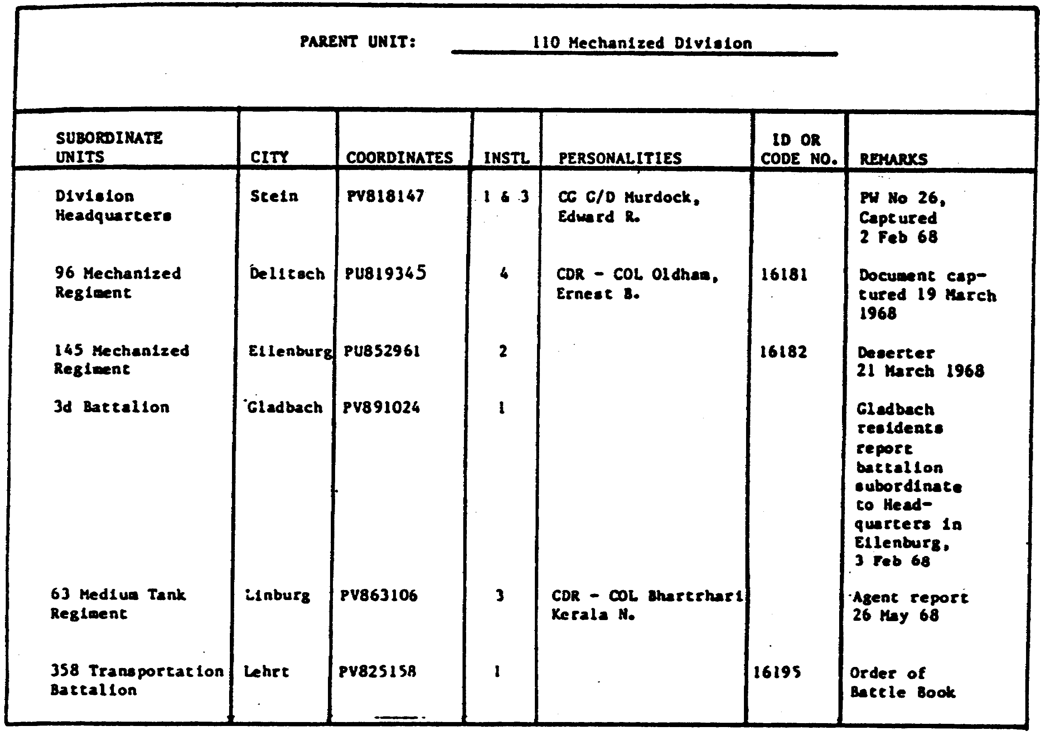

(CLASSIFICATION)

Figure 1-20. Intelligence File Worksheet.

27 IT 0648

25. The coordinate register is a condensed but extensive intelligence file workbook. It can be used with written entries (Figure 1-21) or schematic entries (Figure 1-22).

UNCLASSIFIED

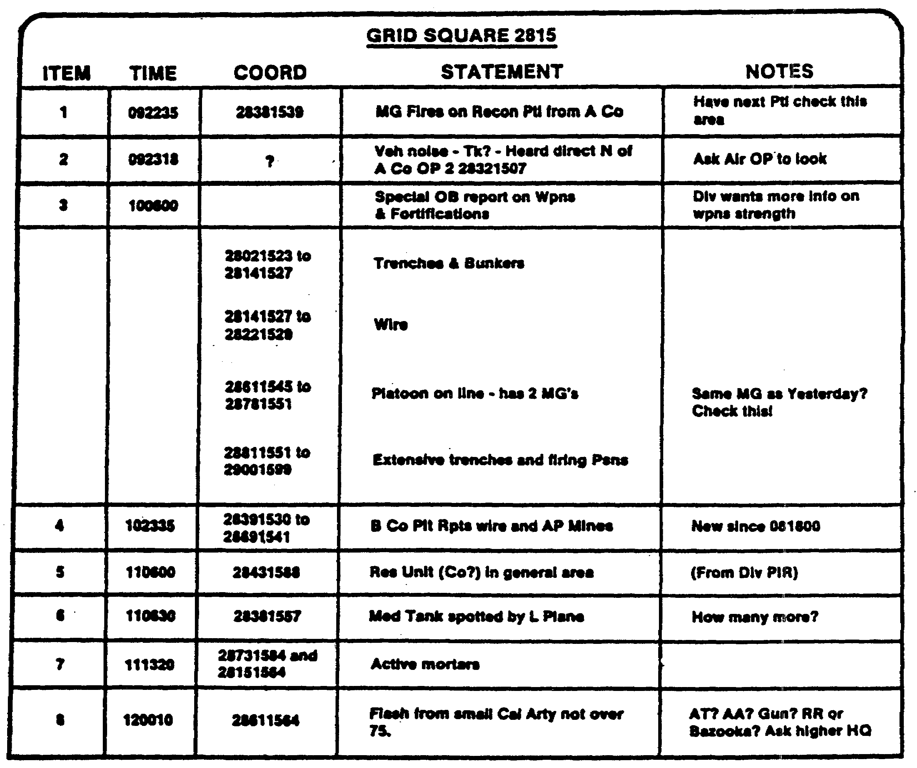

UNCLASSIFIED

Figure 1-21. Coordinate Register with Written Entries.

IT 0648 28

UNCLASSIFIED

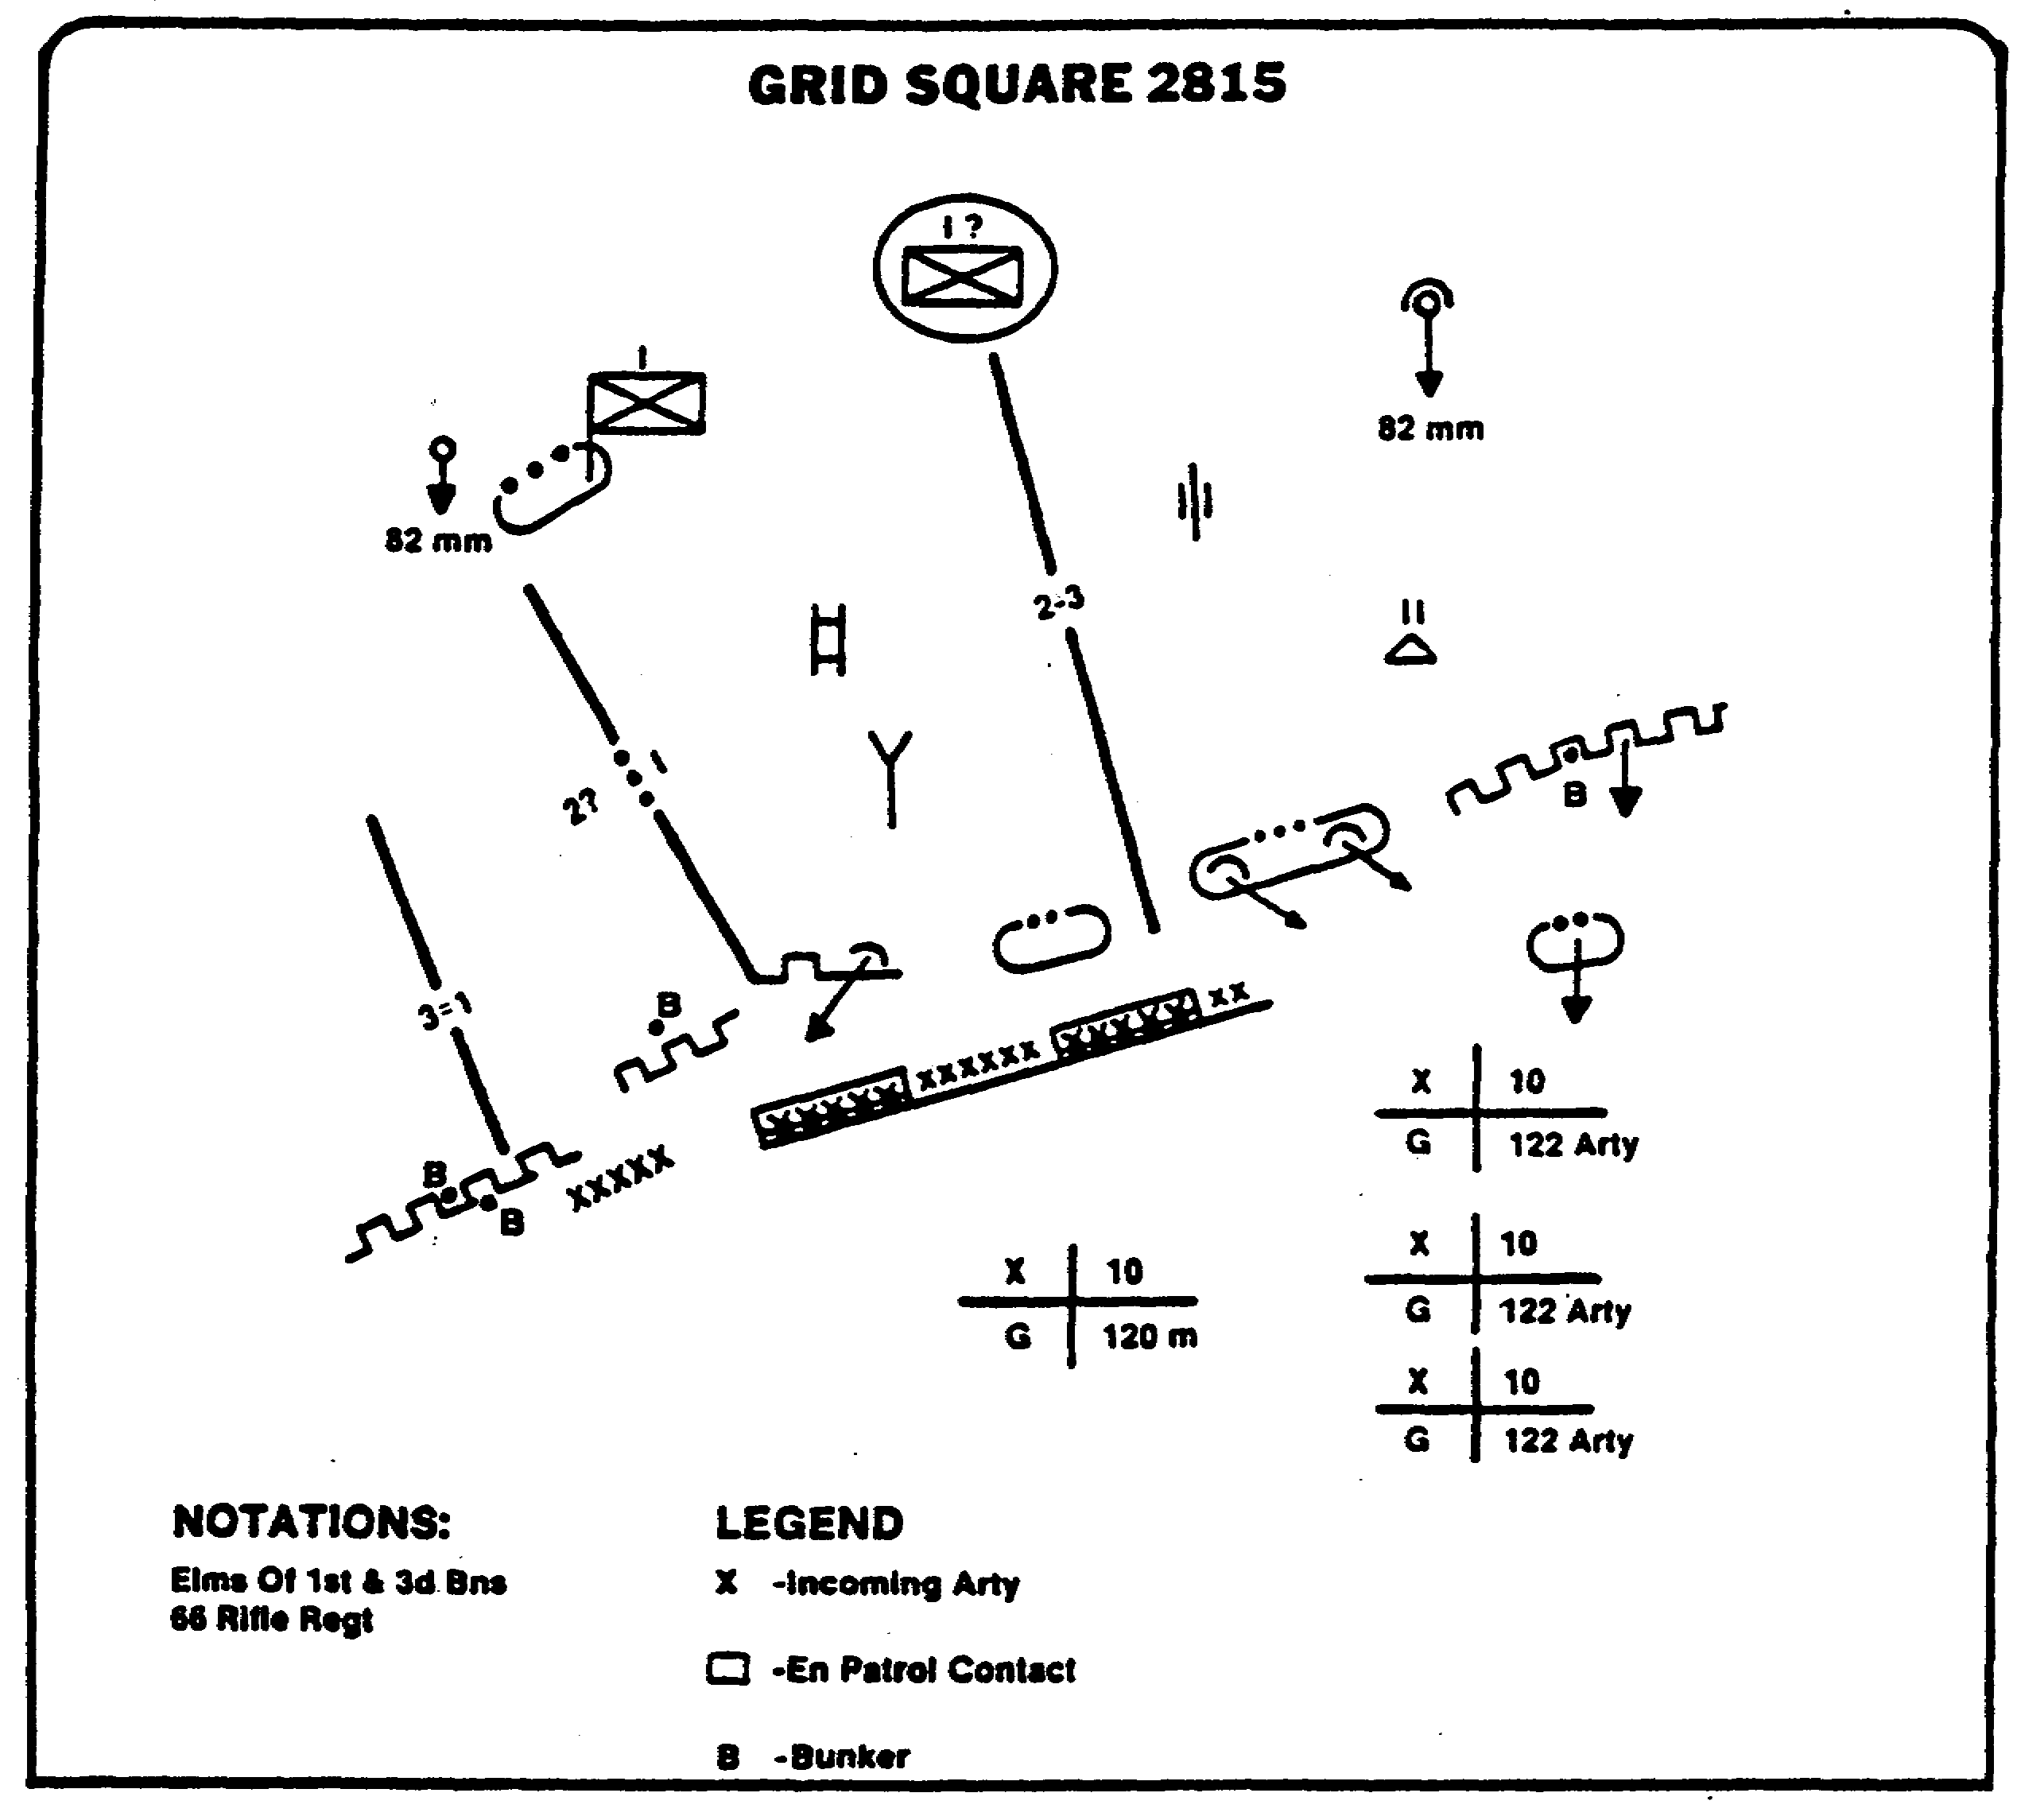

UNCLASSIFIED

Figure 1-22. Coordinate Register with Schematic Entries.

29 IT 0648

26. The daily journal is used to keep a record of Spot reports, shift changes, and important information pertaining to military activity or an exercise (Figure 1-23).

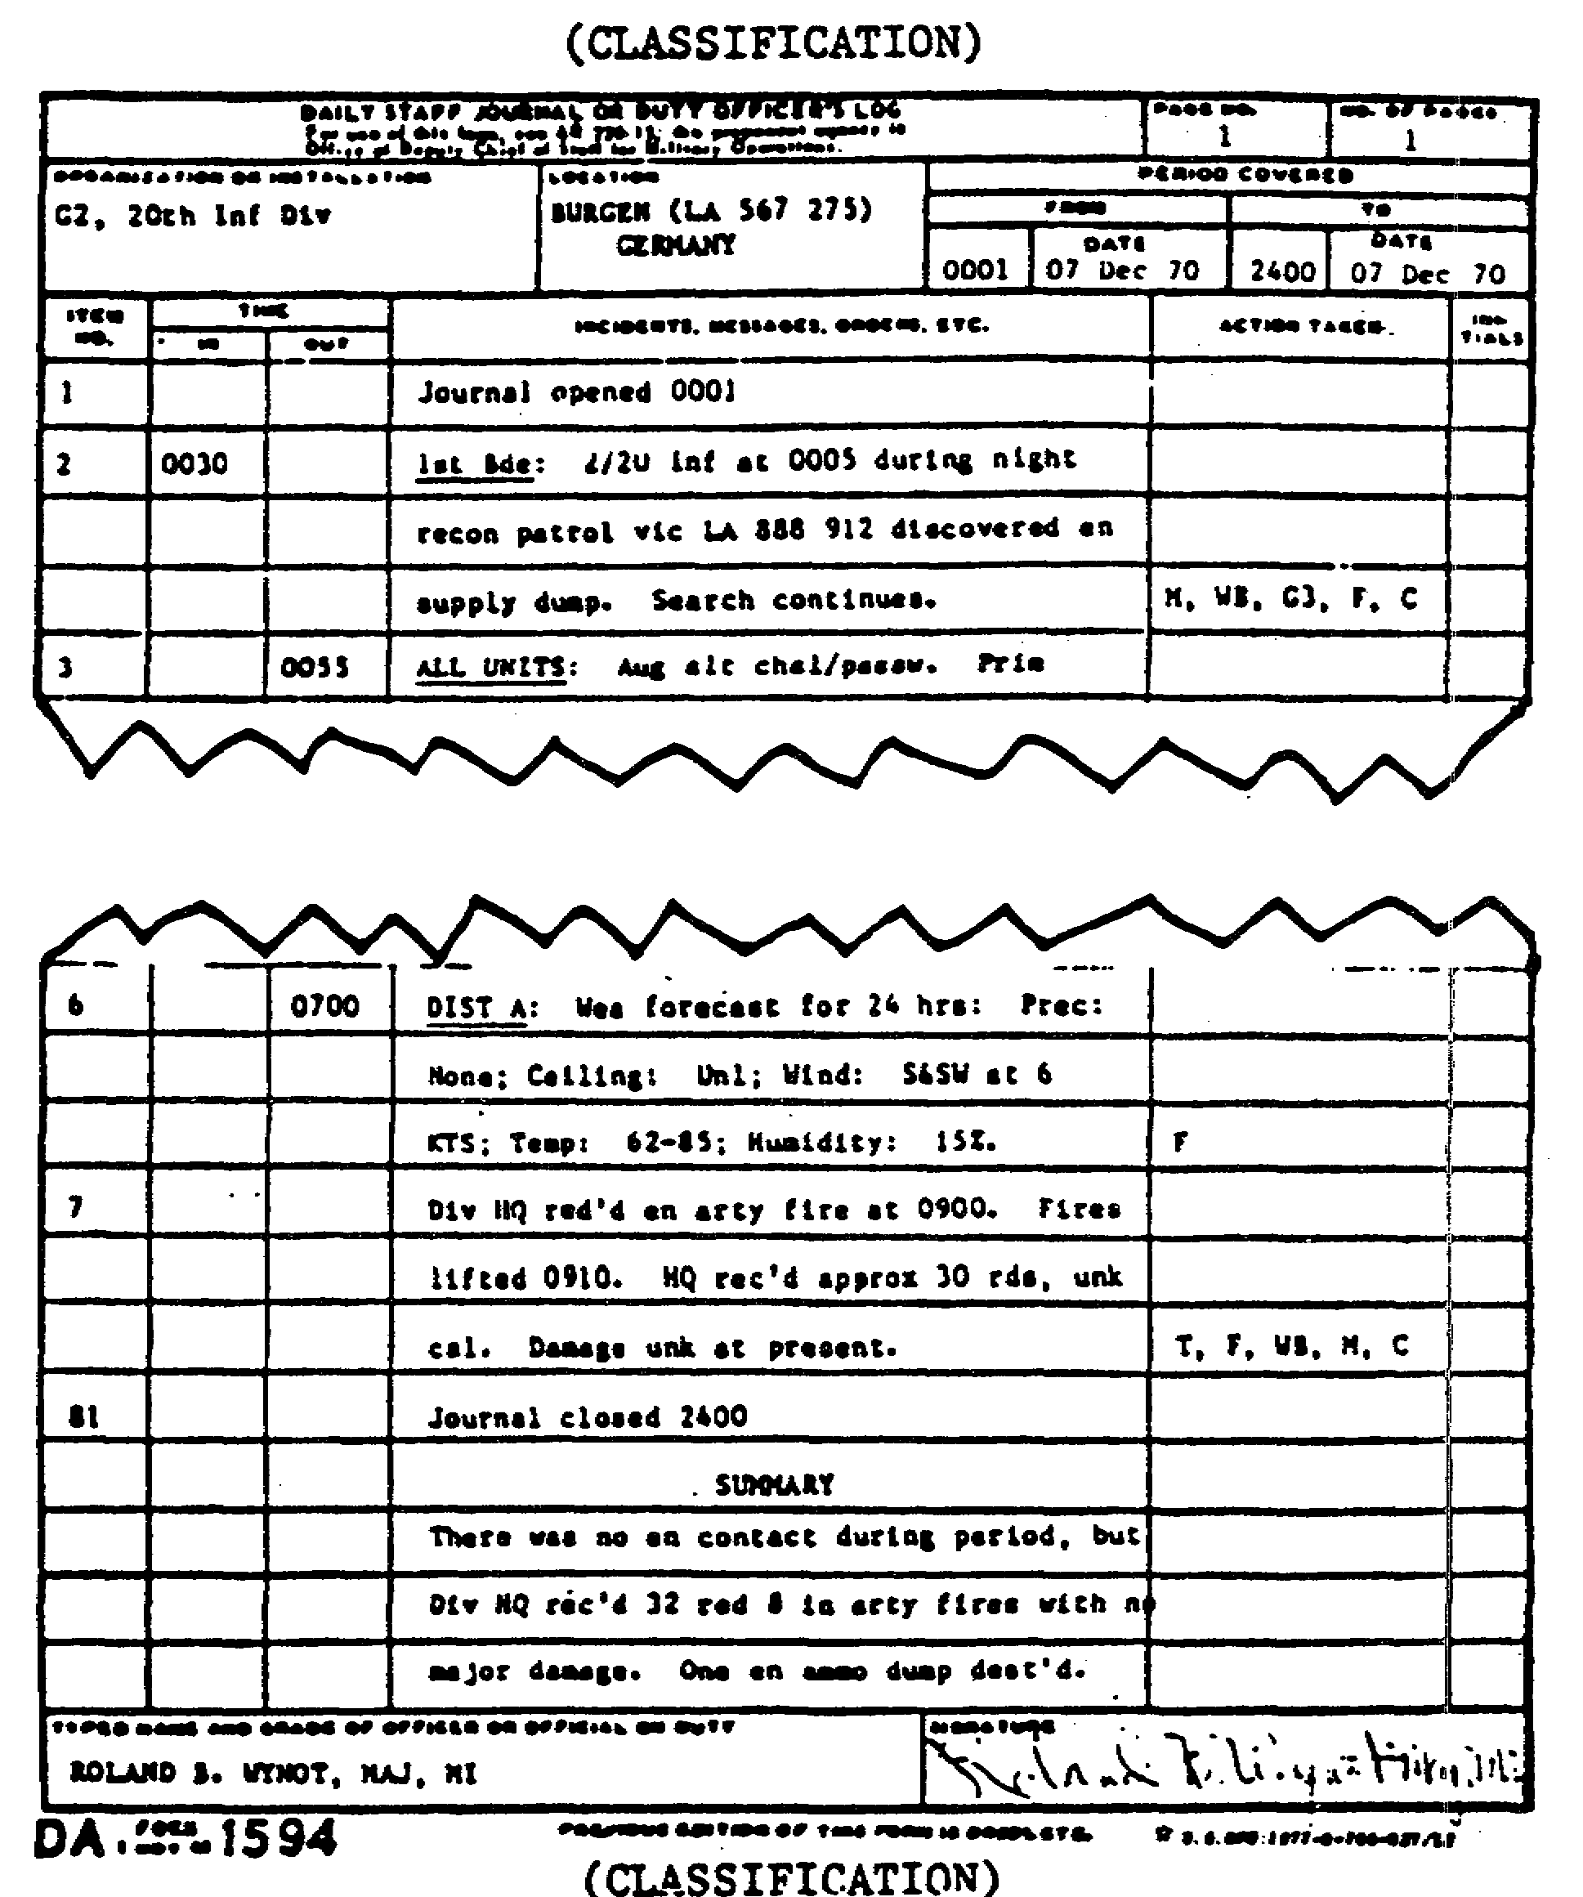

Figure 1-23. Daily Journal.

IT 0648 30

27. The intelligence workbook (Figure 1-24) contains information arranged by subject heading. This arrangement helps to sort, evaluate, interpret information, and prepare intelligence reports. It is not a permanent record, and it is not distributed to an outside agency. The workbook is kept current with obsolete entries deleted. Specialized workbooks on various subjects may be maintained at higher echelons. There is no prescribed format for the intelligence workbook. At division and lower headquarters, index tabs shown in Figure 1-24 are used to label information to be used in the INTSUM (Appendices B-D).

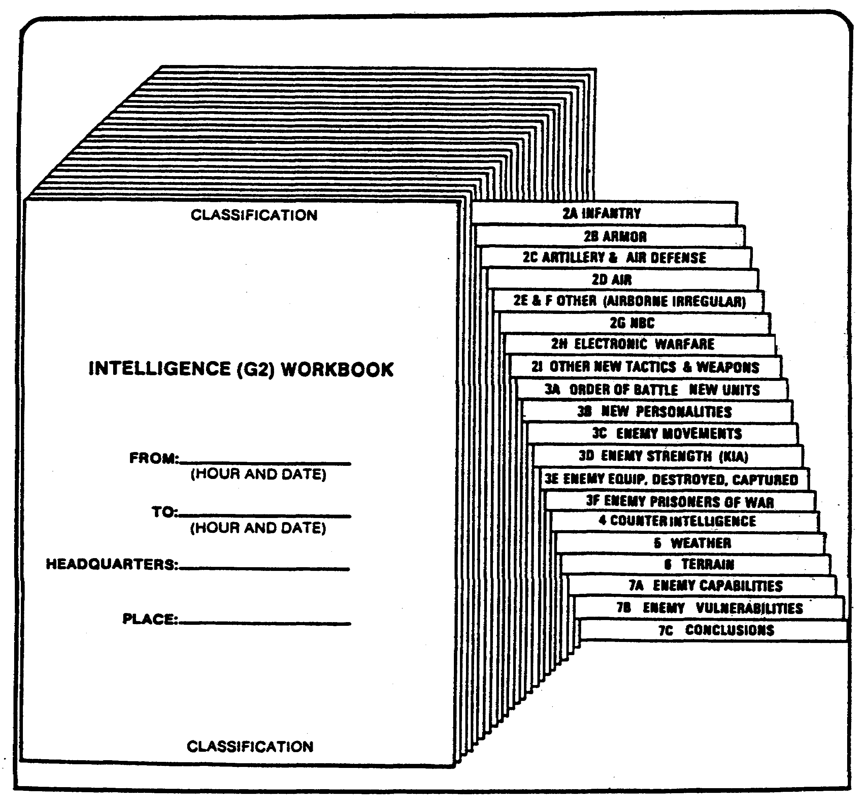

Figure 1-24. Intelligence Workbook.

31 IT 0648

28. Strength work sheet (Figure 1-25) is used to maintain a running numerical tabulation of the enemy's personnel and equipment strengths. This information is recorded on committed units actually engaged with our forces fire support units giving artillery fire from behind the enemy's forward lines and units used as reinforcements that can be brought into action in a short amount of time. There are a lot of blank lines on the work sheet so the intelligence analyst can label them to suit a particular situation.

29. Topical file is maintained when detailed information is desired on new items of enemy equipment, changes of clarification of tactical doctrine, or on any additional data which will clarify enemy OB. Cards or sheets are filed alphabetically by subject.

STRENGTH WORK SHEET UNITS BY TYPE

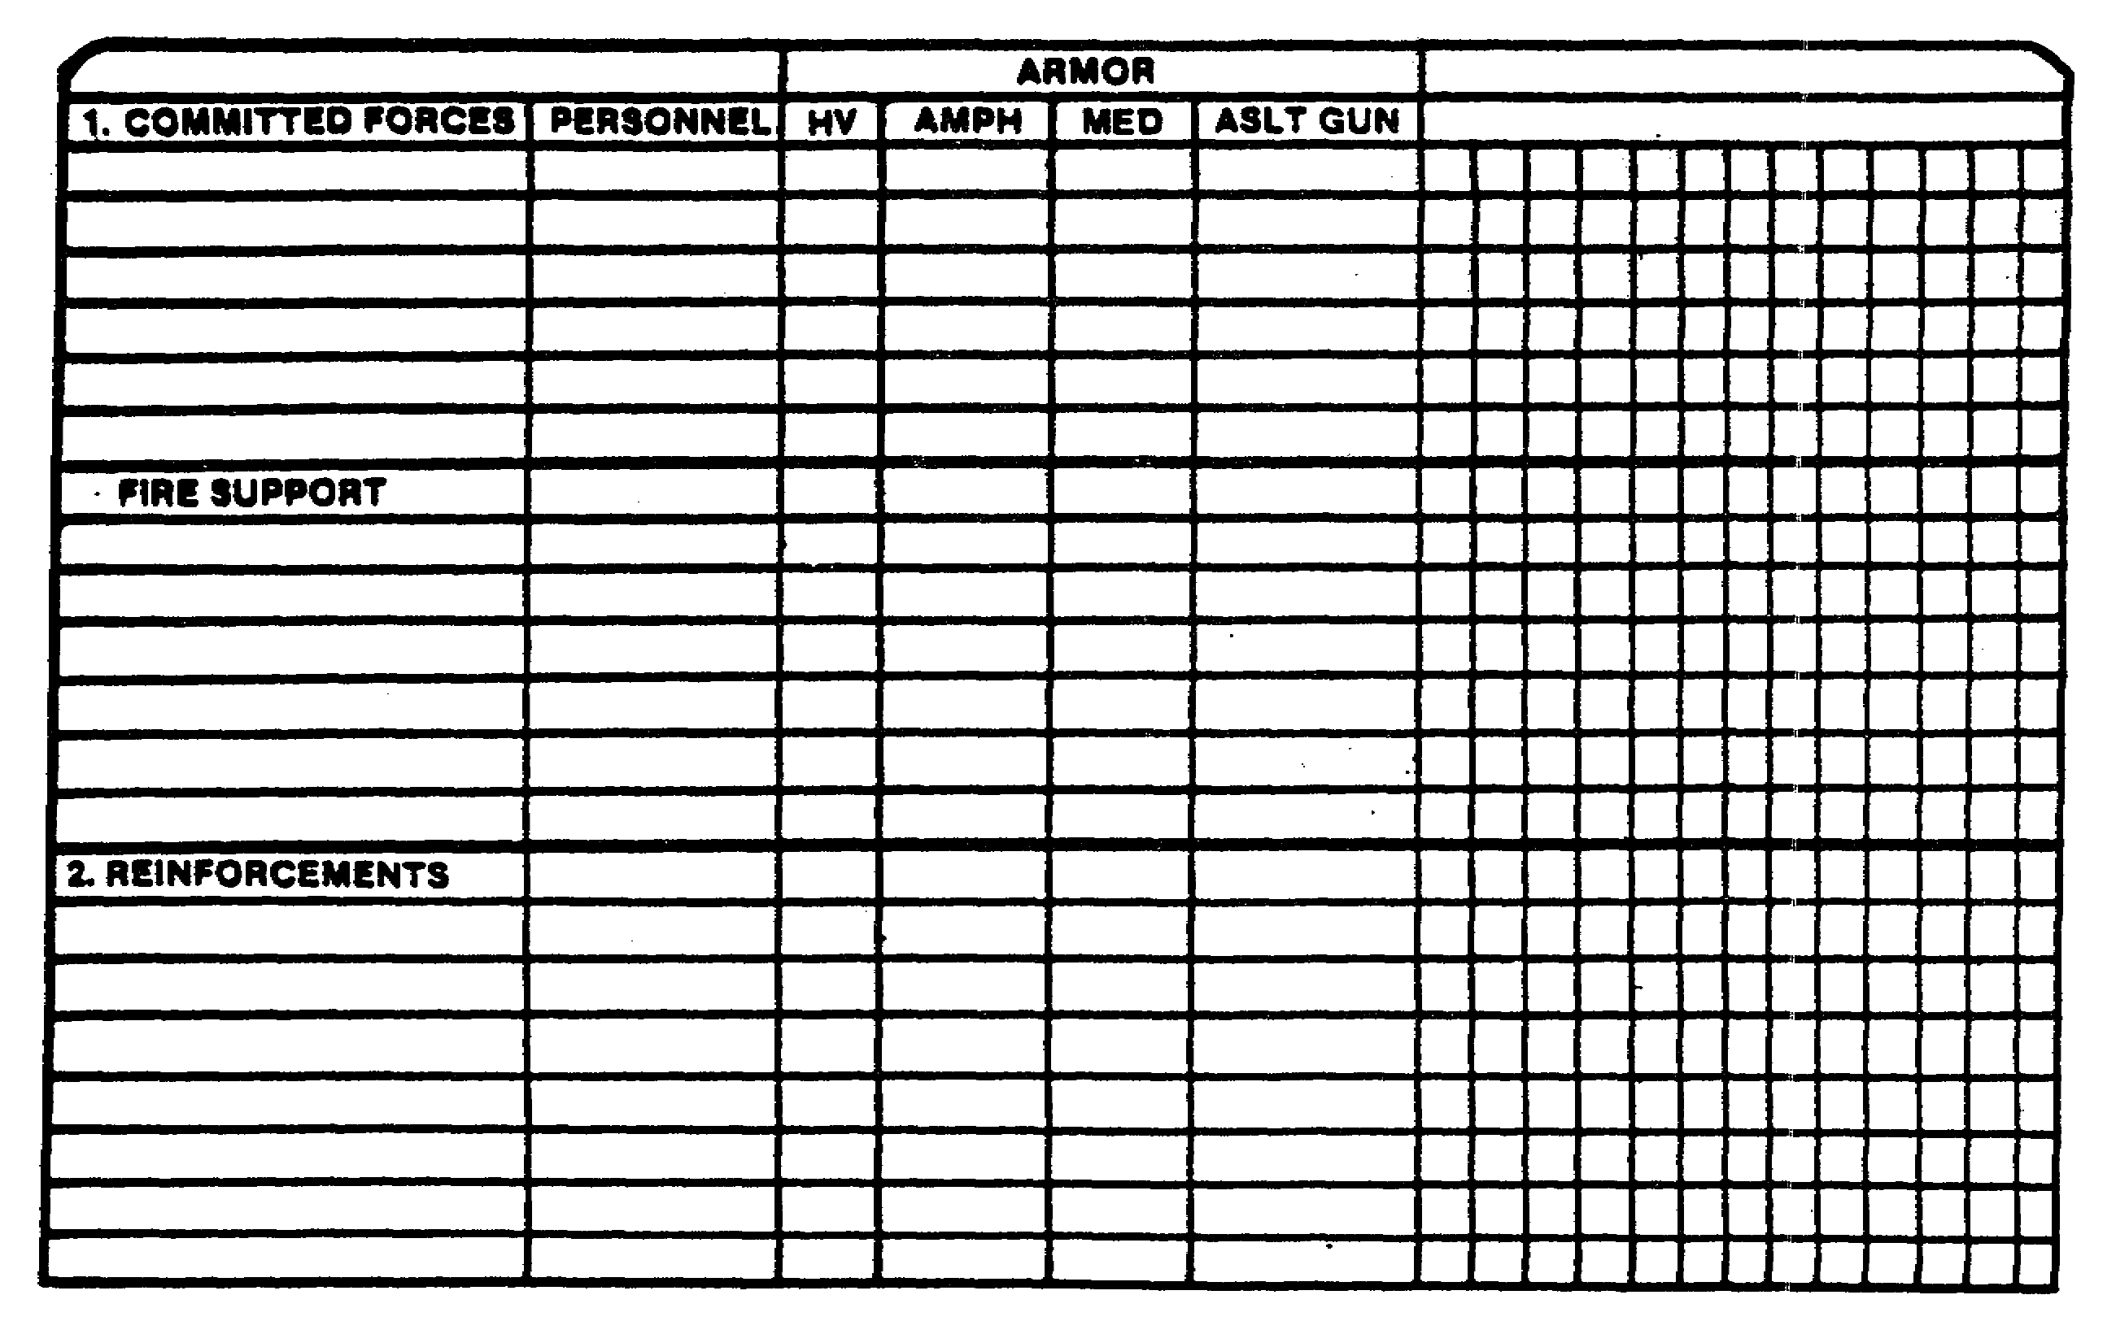

Figure 1-25. Strength Work Sheet.

IT 0648 32

PART D: SOVIET GROUND FORCES

1. Soviet Ground Forces. Though Soviet military activity extends to other parts of the world, the Soviet forces opposite NATO represent a general model for Soviet forces elsewhere, as well as for forces of Soviet allies and surrogates.

a. The ground forces constitute the largest of the five Soviet military services. Soviet armies have always been massive. Today, they are also highly modernized, well equipped, and have great firepower and mobility. Manpower and materiel combined make the present Soviet ground forces a very formidable land army.

b. The main combat power of the ground forces is centered in TDs and MRDs that are deployed under combined arms commands (armies and fronts) and controlled through the Chief of the General Staff. The airborne troops are nominally an arm of the ground forces but are subordinate operationally to the General Staff.

c. In the years immediately following World War II, Stalin maintained massive ground forces to offset the threat of US nuclear power. As the Soviets developed their own strategic nuclear capability and forces, their emphasis shifted away from the ground forces. Under Khruschev, in the late 1950s and early 1960s, the size of the ground forces was reduced, while strategic rocket forces increased in size.

d. The Soviets are concerned about the growing threat from China and wars in the Middle East and Far East. They are increasingly aware that a war may be fought without the use of strategic nuclear weapons. For these reasons, the Brezhnev regime reemphasized the importance of the ground forces. Steady and systematic improvements continue. More than 30 divisions have been added since 1967. Many new weapons and equipment of all types have been introduced. Officer and conscript training has been improved. New tactics, operational art, and strategy also have been developed.

e. The Soviets believe that any future war could involve the use of nuclear weapons and that the initial stage of the war will be decisive. Tactical nuclear weapons have been assigned at all levels from division up. The Soviets have the largest and most effective array of chemical weapons and equipment in the world. They are capable of employing chemical agents from battalion level upward.

f. The Soviets' basic principle of land warfare is violent, sustained, and deep offensive action. Mechanized and armored formations, supported by aviation and artillery, are to seize the initiative at the outset of hostilities, to penetrate the enemy's defenses, and to drive deeply and decisively into the enemy's rear area.

33 IT 0648

2. Groups of forces.

a. In peacetime, the major combined arms commands are located In the 16 military districts in the USSR and in the 4 groups of forces in Eastern Europe: Group of Soviet Forces, Germany, Northern Group of Forces in Poland, Central Group of Forces in Czechoslovakia, and Southern Group of Forces in Hungary. The Soviets also maintain sizable forces In Mongolia (Figure 1-26).

b. In wartime, forces in the groups of forces and military districts will be organized into theaters of military operations (Russian: TVD) and Fronts (army groups) for combat operations. The military districts will continue to function as territorial commands, acting as mobilization and training bases and providing logistical and other support services.

3. The TVD. Besides being a level of command, a TVD is also a geographic entity. It consists of a particular territory, such as a continent or sea, where military forces of the USSR and/or its allies operate In wartime. The Soviets consider the major type of wartime operation to be the theater strategic operation. Within each TVD there are one or more strategic axes. A strategic axis consists of a wide strip of land or sea and the air space above it, leading the armed forces to the enemy's most Important administrative-political and industrial-economic centers. The TVD's most important function will be to orchestrate and control coordinated theater-wide operations Involving Fronts, fleets, independent armies, or flotillas.

a. The Soviet front. The front is the largest field formation in wartime. It is an operational and administrative unit, and its size and composition can vary widely depending on the mission and situation. Roughly equivalent to a US/NATO army group, a front could be composed of four to six armies with organic artillery, missile, air defense, engineer, signal, intelligence, reconnaissance, and rear service units, plus aviation, air assaults, and special purpose forces.

b. The combined arms army (Appendix A) is an operational and administrative organization; it is the basic Soviet field army. A typical combined arms army includes two to four MRDs and one or two TDs, plus artillery, missile, air defense, engineer, chemical defense, signal, intelligence, reconnaissance, and rear support units. By altering the mix of MRDs, TDs, and artillery and missile support, the army can operate in either offensive or defensive roles in different geographical areas and under various operational constraints.

c. The tank army (Appendix A). The tank army is an operational and administrative unit, and, like the combined arms army, is a basic component of a front. The size and composition of the army will depend on the mission, the situation, and the area of operations. A typical tank

IT 0648 34

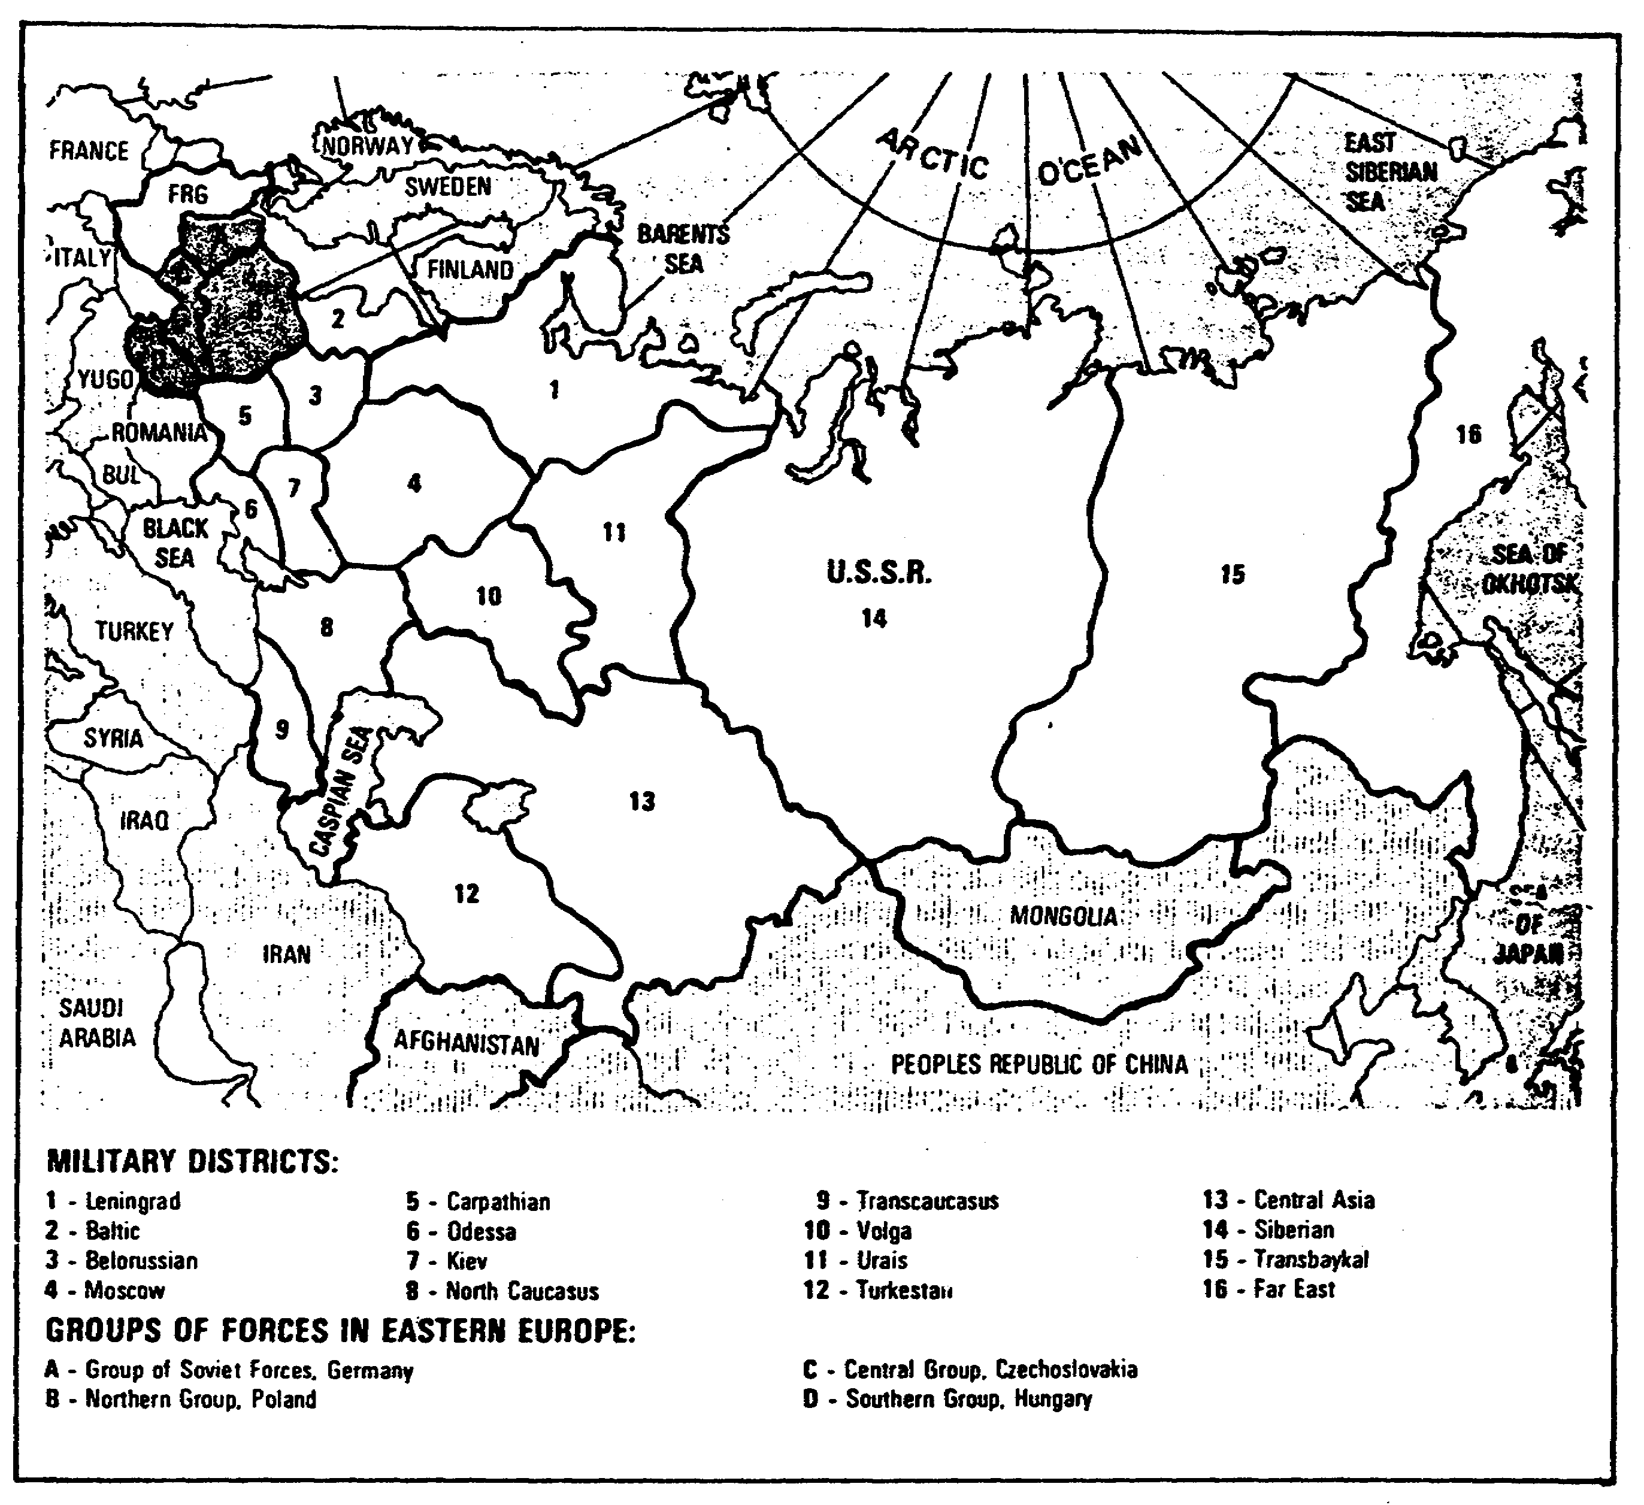

Figure 1-26. Soviet Military Districts and Groups of Forces.

army includes two to four TDs and one or two MRDs, plus artillery, missile, air defense, engineer, chemical defense, signal, intelligence, reconnaissance, and rear service units. A typical role of a tank army is to exploit penetration deep into the enemy's rear areas.

35 IT 0648

d. Soviet new army corps (Appendix A). The Soviet ground forces nave a new corps-type formation which Is roughly equivalent In personnel and equipment to a combined TD and MRD. The new army corps (NAC) features the latest Soviet equipment and has an apparent wartime role as a front-level operational maneuver group (OMG). To enable the formation to conduct relatively independent, fast-moving, deep operations, the primary maneuver elements of the NAC consist of combined arms tank and mechanized brigades, integrating tank and motorized forces down to battalion level. There is no fixed organizational structure at this level.

e. There are three basic types of maneuver divisions In the Soviet ground forces; motorized rifle, tank, and airborne.

4. Strength and deployment of forces.

a. The Soviet ground forces have a total strength of about 1,825,000 men. There are currently 191 maneuver divisions. There are 134 x MRDs, 50 x TDs, and 7 x Abn divisions. Of these maneuver divisions, 30 are stationed in Eastern Europe (East Germany, Poland, Czechoslovakia, and Hungary), 80 are stationed in the European portion of the USSR, 29 in the Central Asian portion, and 52 in Siberia, the Far East, and Mongolia.

b. There are four basic deployment groupings: against NATO, against China, against the Middle East, and a strategic reserve. The largest, best-equipped, and most combat-ready is the group deployed against NATO.

c. Many Soviet divisions are maintained at reduced strength in peace-time, but they can be brought up to operational strength quickly by calling up trained reservists.

d. For over a decade, the Soviets have been modernizing and upgrading their ground forces. This has involved large-scale improvements in mobility, fire power, shock action, command and control, obstacle-crossing capability, air defense, electronic warfare (EW), and logistic support. New and advanced equipment has been introduced.

e. The Soviets have been paying increased attention to the development of power projection forces that would enable them to assert their influence in areas distance from their borders. Naval and air transport resources can be employed to project regular ground force units as well as naval infantry and airborne units and independent air assault brigades.

IT 0648 36

f. Soviet power projection capabilities are impressive in the Persian Gulf region. The Soviets have a substantial number of divisions in varying states of readiness based in the Transcauscasus, North Caucasus, and Turkestan Military Districts. Port facilities in the People's Democratic Republic of Yemen and Ethiopia greatly enhance the operating potential of the Soviet fleet in the Indian Ocean and Arabian Sea.

5. Ground forces organization. Before you attempt to identify the type of unit that contains the pieces of equipment you have reported, you should first become familiar with the ground force organizational guide available in your unit.

a. The Soviet field forces configure their forces into a first and second echelon. They use the second echelon to take advantage of the success of the-first echelon.

b. . The Soviet field forces also place emphasis on river-crossing equipment because of the great number of rivers they would have to cross in a sweep across Europe.

c. The Soviet field forces are organized into company, battalion, regiment, division, (new) corps, army, and front, with company the smallest and front the largest.

d. The organizational guide that you will be using in the field is a classified publication, but the procedures in using it are almost the same as the procedures in (unclassified) Appendix A in this subcourse.

37 IT 0648

LESSON ONE

PRACTICE EXERCISE

The following material will test your grasp of the material covered in this lesson. There is only one correct answer for each item. When you have completed the exercise, check your answers with the answer key that follows. If you answer any item incorrectly, study again that part of the lesson which contains the portion involved.

1. Which OB reference has a collection of unit work sheets containing information on certain types of units?

A. Unit workbook.

B. OB workbook.

C. OB card.

D. OB SITMAP.

2. Which document aids in the sorting, evaluation, and interpretation of information and in the preparation of intelligence reports?

A. Personality file.

B. OB SITMAP.

C. Unit workbook.

D. OB workbook.

3. Which file consists of a collection of explanatory sheets containing information on buildings and their capacities?

A. Topical.

B. OB card.

C. Military installation.

D. Organizational.

IT 0648 38

4. Which of the following contains a running numerical total of the enemy's personnel and equipment strength?

A. Organizational file.

B. Strength work sheet.

C. Personality file.

D. Installation file.

5. In which phase does information become intelligence?

A. Disseminating and using.

B. Processing.

C. Directing.

D. Collecting.

6. Which of the following columns in Figure 1-27 represents the organization of USSR field forces?

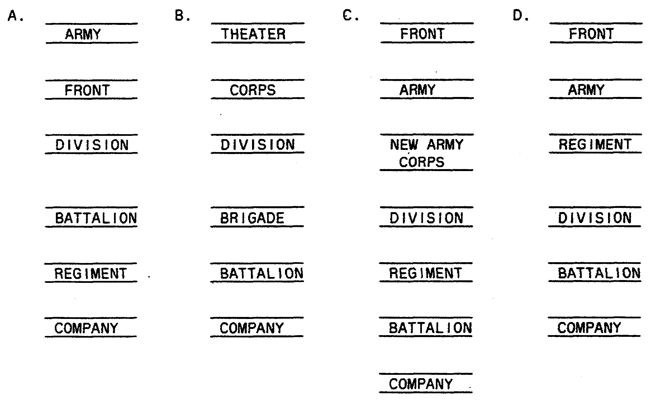

Figure 1-27.

39 IT 0648

7. Which of the following OB battle elements includes transportation?

A. Disposition.

B. Logistics.

C. Strength.

D. Combat Effectiveness.

USE APPENDIX A FOR QUESTIONS 8 -- 10.

8. How many surface-to-surface missile (SSM) brigades (SCUD/SS-23) are in a front?

A. Two.

B. Three.

C. Four.

D. Five.

9. You identified one Big Fred on imagery. Which unit(s)(by name) can be found nearby?

A. MRR of a TD.

B. MRR of a MRD.

C. Arty regiment of a TD or MRD.

D. SSM battalion of a TD or MRD.

10. You identified 5 x cranes, K-61, and 2 x trucks, van, kitchen PAC-170/ 200 within a 500-meter area. Which battalion should these be linked to?

A. Signal.

B. Material support.

C. SSM.

D. Reconnaissance.

IT 0648 40

LESSON ONE

PRACTICE EXERCISE

ANSWER KEY AND FEEDBACK

Item Correct Answer and Feedback

I. A. The unit workbook has a collection of unit work sheets (page 9, para 5).

2. D. The OB workbook aids in the sorting, evaluating, and interpretation of information in the preparation of intelligence reports (page 11, para 6).

3. C. Military installation files consist of a collection of explanatory sheets containing information on buildings and their capacities (page 16, para 10).

4. B. The strength work sheet contains a running numerical total of the enemy's personnel and equipment strength (page 32, para 28).

5. B. In the processing phase information becomes intelligence (page 2, para 2c).

6. C. The organization of Soviet field forces is structured as follows: front, army, NAC, division, regiment, battalion, company (page 37, para 5c).

7. B. Logistics deals with transportation in use (page 5, para 2c).

8. B. Three SSM brigades (SCUD/SS-23) are assigned to a front (page 58).

9. C. An Arty Regt of a TD or MRD can be found near Big Fred (pages 68/76).

10. B. 5 x K-61 cranes, 2 x trucks, van, kitchen PAC-170/200 should be linked to a material support battalion (pages 64/65).

IT 0648 42

LESSON TWO

IMAGERY INTELLIGENCE REFERENCE MATERIAL

MOS Manual Tasks: 301-338-1611
301-338-3612
301-338-4101

OVERVIEW

TASK DESCRIPTION:

In this lesson you will learn to describe imagery intelligence reference material to include information contained in an operations plan (OPLAN), operations order (OPORD), and imagery interpretation (II) references.

LEARNING OBJECTIVE:

ACTIONS: Describe the information and procedures required to use OPLANs, OPORDs, and II reference material.

CONDITIONS: You will be given access to extracts from FM 34-3, FM 101-5-1, STP 34-96D1-SM, STP 34-96D24-SM-TG, and TC 34-55.

STANDARDS: Identification of intelligence reference material to include OPLANs, OPORDs, and II reference material will be IAW FM 34-3, FM 101-5-1, STP 34-96D1-SM, STP 34-96D24-SM-TG, and TC 34-55.

REFERENCES: The material contained in this lesson was derived from the following publications:

FM 34-3.
FM 101-5-1.
STP 34-96D1-SM.
STP 34-96D24-SM-TG.
TC 34-55.

INTRODUCTION

As an IA, you are involved with target intelligence. The target intelligence required for target planning, mission planning, and mission briefings and debriefings, is found in a variety of textual, tabular, and graphic forms. Documents, target materials, and maps and charts considered necessary for a given combat operation are included in the planning phase of the operation.

43 IT 0648

PART A: OPERATIONS PLAN/OPERATIONS ORDER

1. The most important reference material is the OPLAN or the OPORD and related governing directions. The OPLAN/OPORD is the first essential target intelligence reference which describes the type and size of operation. The OPLAN and its annexes contain specific types and forms of target intelligence reference materials required to support the unit mission. Sample OPORD is in FM 101-5, Staff Organization and Operations.

2. The intelligence annex (Appendices G and H) is an integral part of any OPLAN or OPORD. The purpose of the annex is to provide details not incorporated into the basic order. The annex should be as brief as possible yet provide sufficient information to accomplish the mission. It is used to keep the basic text of the order short and allows the selective distribution of its contents. The annex is used to disseminate PIR, IR, and intelligence tasks.

a. The intelligence annex provides information and direction to subordinate units of the command. It is usually prepared at division and above by the G2 supported by the ASPS and CM&D sections. It is unique among annexes in that it has provisions for requesting information from higher and adjacent units needed to support the unit collection plan.

b. The intelligence annex may contain such a volume of information that additional documents are needed to organize the data and convey necessary instructions. The additional documents are called appendices. Each additional document covers one aspect of intelligence like OB, counterintelligence (CI), or reconnaissance and surveillance (R&S).

3. The R&S appendix (Appendix I) is the responsibility of the (32. Its purpose is to assist in the planning and execution of intelligence collection in the command's area of influence. Much of the information in the R&S appendix is in graphic form as overlays. The R&S appendix normally contains three overlays--tabs A, B, and C. Tab A (route overlay) and tab B (area overlay) are always prepared as part of the R&S appendix. Tab C (point overlay) may be prepared when necessary. Tabs are prepared under the supervision of the G2 Air or the tactical surveillance officer (TSO) and in coordination with G2 plans and the CMO.

a. On the route overlay (Tab A of Appendix I) the letter R prefix designates axial routes while the letter Z prefix designates lateral routes. A selected route may or may not traverse the length or width of the area and is terminated unless it can be tied to another route within 16 kilometers (km). Termination of an R route can be avoided by traveling a Z route for less than 16 km.

b. On the area overlay (Tab B of Appendix I) the letters of the alphabet, except I, O, R, and Z, are used as prefixes to numerical designations applied to search areas. Search areas nearest the line of contact are

IT 0648 44

given the prefix A followed by a numerical designation. The next row of areas is given the prefix B, and so on. The size of each area depends on search methods, sensor, terrain, enemy defenses, intensity of search, and information being sought.

c. The point overlay (Tab C of Appendix I) supports development of specific targets. A pinpoint representing a coordinate, surrounded by a circle with a numerical designation is plotted on the overlay, A concentration list is placed on the overlay to describe the targets.

PART B: IMAGERY ANALYSIS REFERENCES

1. The intelligence library is set up for you to become well-informed in intelligence. In this facility, you should find the most recent photographs, keys, maps, and charts; manuals and documents concerning the latest intelligence methods and techniques; current information on world situations; documents that reflect the thinking and the policies of national and military leaders; reports and summaries of enemy activity; and documents concerning the history, geography, economy, and government of all nations. The library must be so arranged that the librarian can quickly find any particular document needed. Also, the librarian must be able to rapidly locate and collect all the material available on any given subject.

2. Basic reference materials. Target planning, study, and briefing require a wealth of information. Essential target information must be accumulated and assembled for ready use. Some of this information has been compiled and placed in basic intelligence reference materials and publications by the Department of Defense (DOD) and military departments. Some of the target intelligence required to support the unit's mission, however, must be located and compiled at the unit level. You should be familiar with the origin and content of the most frequently used basic intelligence references.

3. First, you should be able to find and research information which you need in your work; second, you need to locate information requested by others. This means you must know what reference material to look for and how to use each item. Because of the variety of forms and vast number of different publications that relate to target intelligence, all of them cannot be reviewed; however, those frequently used to analyze, select, and plan targets are as follows:

a. Target folders (Appendix J) are repositories of target information on specific targets, target concentrations, and target complexes. They consist of envelopes and binders of charts, mosaics, graphic aids, photos, and textual target information prepared for use in studying targets, planning missions, and executing air strikes against preassigned targets. Some of the materials and information contained in the target folders are

45 IT 0648

usually prepared by higher headquarters. IAs must add to, expand, and maintain these folders at the unit level. These folders can have several formats, depending on the target, weapon system; and command's standing operating procedure (SOP). Each folder places a comprehensive source of target intelligence at the target planner's fingertips. Refer to ACCP subcourse IT 0659 for additional studies, if so desired.

b. Imagery analysis reports (Appendix K) are evaluated and information is collected through imagery analysis. Imagery' analysis reports include the reconnaissance exploitation report (RECCEXREP), radar exploitation report (RADAREXREP), immediate/supplemental interpretation report (IPIR/SUPIR), and the imagery intelligence report (IIR)(Appendix K). Aerial imagery has proven to be a valuable source of target intelligence because it provides precise locational and accurate dimensional data. Source of target intelligence gained by ground observation and reporting can be confirmed or denied and expanded or supplemented by imagery analysis. At the unit level, imagery analysis reports help provide the PIR and IR. The PIR stated in the intelligence annexes of OPLANs and OPORDs require constant update information as well as new data. In a combat tactical environment, basic intelligence requirements for some installations have become so common they are termed standard PIR. Refer to ACCP subcourses IT 0667 and IT 0687 for additional studies, if so desired.

c. Information on airfield and seaplane stations around the world is covered in 41 different volumes, each covering a specific area. Usually one country is included in a volume. Each volume contains an airfield or seaplane evaluation sheet for each usable or potentially important air facility. The airfield or seaplane station must have a runway that is 2,000 feet (ft) or longer. Each volume contains a chart for each country or geographical area. The chart portrays, by means of appropriate symbols, the location, type, and runway length.

d. Basic encyclopedia (BE) is published periodically in two volumes. Volume I is a numerical listing of installations by BE number without regard to country. Volume II is a categorical listing, with installations and places arranged alphabetically by country within that category. Currently, BEs are produced for broad geographical areas of the world.

e. Target data inventories (TDIs) are basically the same as the BEs. They are produced by identical methods and procedures and distributed to the same recipients as the BEs; however, only two volumes of the TDI are produced for each major area. Volume I is an alphabetical listing of data by target complex name; Volume II lists the same information by category code number.

NOTE: These documents extend and expand most of the data listed in BEs. Thus, TDI information is more specific than BE data because the information listed in the TDIs is used with the BE data. TDI are usually assigned only to organizations authorized to stock: BEs.

IT 0648 46

f. TDI handbooks are employed by DOD. An intelligence data handling system (IDHS) is used to store, process, and retrieve the data for the thousands of targets listed in the BEs and TDIs. Thus, the IDHS requires standardized terminology and codes to function. Various handbooks are produced to help Intelligence personnel Interpret the formats and codes used with the system. The TDI handbook serves the purpose for the TDIs. These handbooks are produced for the same areas as the TDIs.

g. Imagery interpretation (11) Keys (Appendix L) are reference material designed to facilitate rapid and accurate Identification and determination of the significance of objects by the IA. Furthermore, they are designed to aid IAs in identifying and analyzing natural, manmade, and equipment features on various types of aerial imagery. Ii Keys are further discussed in ACCP subcourse IT 0643.

4. Integrated target reference documents are periodically revised to furnish the users with current target intelligence on targets throughout the world. They are produced from computer punchcards which contain the coded target information. Individual sheets or pages of the BEs and TDIs are machine-printed from the computer cards. After the pages are printed they are reduced In size, bound, and covered to form a catalog-type book. Although nearly all known installations of strategic and tactical significance are listed in this series of Defense Intelligence Agency (DIA) publications, they are not intended to present complete information about the installations they list. These documents do provide, however, a central reference of functional and locational data that will aid both strategic and tactical target planners. They are issued to the military departments, military commands, and DOD agencies that require them in their work. These documents, as well as many other published references, are used in compiling target intelligence needed for mission planning.

47 IT 0648

LESSON TWO

PRACTICE EXERCISE

The following material will test your grasp of the material covered in this lesson. There is only one correct answer for each item. When you have completed the exercise, check your answers with the answer key that follows. If you answer any item incorrectly, study again that part of the lesson which contains the portion involved.

1. Which basic reference material is published in two volumes, one of which contains a categorical listing with installation and places arranged alphabetically by country within that category?

A. Target folder.

B. TDI.

C. BE.

D. II keys.

2. Which' basic reference material is used to store, process, and retrieve the data for thousands of targets through IDHS?

A. TDI handbooks.

B. IA reports.

C. OPLAN.

D. II keys.

3. What is one of the most important reference material describing the size and type of operations?

A. R&S appendix.

B. OPLAN.

C. Target folder.

D. Intelligence workbook.

IT 0648 48

4. Who is responsible for the R&S appendix?

A. G2.

B. G2 air.

C. Commander.

D. TSO.

5. Which 11 key is a collection of item keys concerned with principal objects or conditions within a given category?

A. Direct.

B. Associate.

C. Item.

D. Subject.

49 IT 0648

LESSON TWO

PRACTICE EXERCISE

ANSWER KEY AND FEEDBACK

Item Correct Answer and Feedback

1. C. The BE is published in two volumes, Volume II is a categorical listing with installations and arranged alphabetically by country within that category (page 46, para 3d).

2. A. TDI handbooks are used to store, process, and retrieve the data for thousands of targets through IDHS (page 47, para 3f).

3. B. The OPLAN is the most important reference material describing the size and type of operations (page 44, para 1).

4. A. The G2 is responsible for the R&S appendix (page 44, para 3).

5. D. A subject key is a collection of item keys concerned with principal objects or conditions within the given subject category (page 136, subpara b).

IT 0648 50

